Using the --record flag:

You would have noticed that the “change-cause” field is empty in the rollout history output. We can use the --record flag to save the command used to create/update a deployment against the revision number.

You can now see that the change-cause is recorded for the revision 2 of this deployment.

Let’s make some more changes. In the example below, we are editing the deployment and changing the image from nginx:1.17 to nginx:latest while making use of the –record flag.

master $ kubectl set image deployment nginx nginx=nginx:1.17 --record

deployment.extensions/nginx image updated

master $master $

master $ kubectl rollout history deployment nginx

deployment.extensions/nginx

REVISION CHANGE-CAUSE

1 <none>

2 kubectl set image deployment nginx nginx=nginx:1.17 --record=true

master $ kubectl edit deployments. nginx --record

deployment.extensions/nginx edited

master $ kubectl rollout history deployment nginx

REVISION CHANGE-CAUSE

1 <none>

2 kubectl set image deployment nginx nginx=nginx:1.17 --record=true

3 kubectl edit deployments. nginx --record=true

master $ kubectl rollout history deployment nginx --revision=3

deployment.extensions/nginx with revision #3

Pod Template: Labels: app=nginx

pod-template-hash=df6487dc Annotations: kubernetes.io/change-cause: kubectl edit deployments. nginx --record=true

Containers:

nginx:

Image: nginx:latest

Port: <none>

Host Port: <none>

Environment: <none>

Mounts: <none>

Volumes: <none>

Undo a change:

Let’s now rollback to the previous revision:

master $ kubectl rollout undo deployment nginx

deployment.extensions/nginx rolled back

master $ kubectl rollout history deployment nginx

deployment.extensions/nginxREVISION CHANGE-CAUSE

1 <none>

3 kubectl edit deployments. nginx --record=true

4 kubectl set image deployment nginx nginx=nginx:1.17 --record=true

master $ kubectl rollout history deployment nginx --revision=4

deployment.extensions/nginx with revision #4Pod Template:

Labels: app=nginx pod-template-hash=b99b98f9

Annotations: kubernetes.io/change-cause: kubectl set image deployment nginx nginx=nginx:1.17 --record=true

Containers:

nginx:

Image: nginx:1.17

Port: <none>

Host Port: <none>

Environment: <none>

Mounts: <none>

Volumes: <none>

master $ kubectl describe deployments. nginx | grep -i image:

Image: nginx:1.17

With this, we have rolled back to the previous version of the deployment with the image = nginx:1.17.

**Jobs and CronJobs**

When we have a requirement that we need a certain type of job to execute and finish like batch processing, data processing, analytics then on that time rather than creating and pod we can create any job.

Because the pods keep on restarting when it got terminated but we need to start, execute and finish. The task which are meant to live for a short period of time.

Like when we do the following command:

**docker run ubuntu expr 3+2**

It will run execute and terminate, since the task was completed.

We can replicate the same with Kubernetes with job.

apiVersion: v1

kind: Pod

metadata:

  name: Math-app-pod

  labels:

    name: math-app-pod

spec:

  containers:

  - name: math-app-pod

    image: ubuntu

    command: ["expr", "3", "+", "2"]

By default, ubuntu will run execute and finish and so did the pod. It will go to the complete state. But in attempt of keep on running Kubernetes will keep this pod restarting. This will happen continuously until the threshold is reached. This is default behaviour of the pod and there is a property mentioned under the **spec** which is **restartPolicy**. By default, its value is **Always**.

We can set this value to **Never** to stop restarting.

We can create a job in place of this pod.

apiVersion: batch/v1

kind: Job

metadata:

  name: math-app-job

  labels:

    name: math-app-job

spec:

  template:

    spec:

      containers:

      - name: math-app-pod

        image: ubuntu

        command: ["expr", "3", "+", "2"]

      restartPolicy: Never

**kubectl create -f math-add-job.yaml**: To create a job

**kubectl get jobs**: To get all the jobs

Kubernetes internally create a pod for this and once it got completed it will not try to restart.

We can see the output from the logs of the pod.

**kubectl logs <pod-name>**

To run multiple jobs, we can add **completion** property under **spec**. By default, the pods are created one after another like 2nd pod is created only after the 1st pod is started and finished. If the pod got failed it will try to bring a new pod until it reaches the required number of jobs mentioned. So, we can run the jobs parallelly to save some time. To add parallelism, we can add **parallelism** property under the **spec**.

spec:

  completions: 3

  parallelism: 3

  template:

    spec:

      containers:

      - name: random-error-job

        image: kodekloud/random-error

      restartPolicy: Never

CronJob is a job that can be scheduled with cron expression

apiVersion: batch/v1beta1

kind: CronJob

metadata:

  name: math-cronjob

  labels:

    name: math-cronjob

spec:

  schedule: "\*/1 \* \* \* \*"

  jobTemplate:

    spec:

      completions: 3

      parallelism: 3

      template:

        spec:

          containers:

          - name: math-cronjob

            image: ubuntu

            command: ["expr", "3", "+", "2"]

          restartPolicy: Never

**kubectl create -f math-cronjob.yaml**

**kubectl get cronjob**

**Kubernetes Services/Ingress**

Some references for ingress:

<https://medium.com/digitalfrontiers/kubernetes-ingress-with-nginx-93bdc1ce5fa9>

<https://medium.com/devops-mojo/kubernetes-ingress-overview-what-is-kubernetes-ingress-introduction-to-k8s-ingress-b0f81525ffe2>

<https://katharharshal1.medium.com/setup-nginx-ingress-controller-on-kubernetes-cluster-dd48b2b1ab61>

<https://www.containiq.com/post/kubernetes-ingress>  
<https://www.edc4it.com/blog/k8s-ingress-tls-termination>

ingress controller:

<https://raw.githubusercontent.com/kubernetes/ingress-nginx/nginx-0.27.0/deploy/static/mandatory.yaml>

<https://raw.githubusercontent.com/kubernetes/ingress-nginx/nginx-0.27.0/deploy/static/provider/cloud-generic.yaml>

minikube addons enable ingress  
minikube addons enable metrics-server  
minikube dashboard

kubectl proxy --port=8080

curl http://localhost:8080/api/

<https://github.com/nginxinc/kubernetes-ingress>

<https://kubernetes.io/docs/concepts/services-networking/ingress/>

kubectl get all --all-namespaces  
kubectl get cm --all-namespaces  
kubectl describe cm kube-root-ca.crt -n <namespace>  
kubectl delete services,deployments,rs,pods,cm,secrets,job.batch --all -n <namespace>  
kubectl get cm,secrets --all-namespaces  
kubectl delete --all -n ingress-nginx

kubectl create deployment hello-minikube --image=kicbase/echo-server:1.0

kubectl expose deployment hello-minikube --type=NodePort --port=8080

kubectl get services hello-minikube

minikube service hello-minikube

kubectl port-forward service/hello-minikube 7080:8080

kubectl create deployment balanced --image=kicbase/echo-server:1.0

kubectl expose deployment balanced --type=LoadBalancer --port=8080

minikube tunnel

kubectl get services balanced

minikube config set memory 9001

minikube addons list

minikube start -p aged --kubernetes-version=v1.16.1

minikube delete --all

Now, in k8s version **1.20+** we can create an Ingress resource from the imperative way like this:-

**Format - kubectl create ingress <ingress-name> --rule="host/path=service:port"**  
**Example - kubectl create ingress ingress-test --rule="wear.my-online-store.com/wear\*=wear-service:80"**

Find more information and examples in the below reference link:-

<https://kubernetes.io/docs/reference/generated/kubectl/kubectl-commands#-em-ingress-em->

**References:-**

<https://kubernetes.io/docs/concepts/services-networking/ingress>  
<https://kubernetes.io/docs/concepts/services-networking/ingress/#path-types>

**if minikube driver is none then follow this:**

minikube addons enable ingress / else download all the ingress controller configs and apply them

kubectl apply -f namespace.yaml

kubectl apply -f deployments.yaml

kubectl apply -f services.yaml

kubectl apply -f ingress.yaml / ingress-resource.yaml

minikube tunnel  
update /etc/host file -> 127.0.0.1 app.reactor.com

we are setting 127.0.0.1 not 192.168.49.2 because in minikube local ingress is in 127.0.0.1

14:35:14:~ kubectl get ingress -A

**NAMESPACE NAME CLASS HOSTS ADDRESS PORTS AGE**

default echo <none> app.reactor.com 192.168.49.2 80 6h6m

Don’t use this annotation in metadata nginx.ingress.kubernetes.io/rewrite-target: /

It is used to rewrite the path. **/echo/sample** will be converted to **/**

Ingress resource port is always set to 80/443

---

apiVersion: networking.k8s.io/v1

kind: Ingress

metadata:

name: echo

# annotations:

# nginx.ingress.kubernetes.io/rewrite-target: /

spec:

rules:

- host: app.reactor.com

http:

paths:

- backend:

service:

name: echo

port:

number: 80

pathType: Prefix

path: /echo

---

apiVersion: apps/v1

kind: Deployment

metadata:

name: echo

labels:

type: echo

spec:

replicas: 2

selector:

matchLabels:

type: echo

template:

metadata:

labels:

type: echo

spec:

containers:

- name: echo

image: abhishek1009/echo:latest

ports:

- containerPort: 8000

---

apiVersion: v1

kind: Service

metadata:

name: echo

spec:

selector:

type: echo

ports:

- port: 80

targetPort: 8000

We can write as many rules as we want.

**Network Policies**

Let’s say there is a DB pod and one frontend pod and one backend pod. If we create a service to expose the DB pod via service into some specific port then the DB pod will be accessible by all other pods, but we don’t want that to happen. So we can create some rules or **NetworkPolicy** on DB pod that who can access the pod and whom the db pod can access. There are the ingress policy and egress policy. As name suggest ingress means incoming traffic rule to specific pod and egress means outgoing traffic rules to specific pods.

Kubernetes is configured with all allow rule, that means any pod in any node can connect to any pod. To apply any ingress or egress rule we have to apply **NetworkPolicy**. Just like services and replicasets/deployment Kubernetes will use label and selectors to apply the policies.

---

apiVersion: networking.k8s.io/v1

kind: NetworkPolicy

metadata:

name: nginx-policy

spec:

podSelector:

matchLabels:

app: nginx

policyTypes:

- Ingress

- Egress

ingress:

- from:

- podSelector:

matchLabels:

type: frontend-api

namespaceSelector:

matchLabels:

env: prod

ipBlock:

cidr: 192.168.5.10/32

ports:

- protocol: TCP

port: 80

egress:

- to:

- podSelector:

matchLabels:

type: backend-api

namespaceSelector:

matchLabels:

env: prod

ipBlock:

cidr: 192.168.5.17/32

ports:

- protocol: TCP

port: 8080

---

apiVersion: networking.k8s.io/v1

kind: NetworkPolicy

metadata:

name: db-policy

spec:

podSelector:

matchLabels:

type: master-db

policyTypes:

- Ingres

ingress:

- from:

- podSelector:

matchLabels:

type: backend-api

namespaceSelector:

matchLabels:

env: prod

ipBlock:

cidr: 192.168.5.10/32

ports:

- protocol: TCP

port: 3306

In the previous two network policy yamls, for one policy there is only ingress and for another there are both. So by this configuration the first pof only allow ingress and second pod allow both ingress and egress. But we must mention that in **policyType** otherwise no configuration will work.

If we look closely then we can see that **to** and **from** is array so if we give podSelector, namespaceSelector and ipBlock in same element then it will act as an and operation , that means from the app in namespace prod has the matching label and has that specific ip can only access this pod or we can say that this pod will only accept connection from a pod if that pod fulfilled all these 3 conditions.

If these conditions are given in separate items, then it will act as or operation like the following configuration.

- from:

- podSelector:

matchLabels:

type: backend-api

namespaceSelector:

matchLabels:

env: prod

- ipBlock:

cidr: 192.168.5.10/32

- from:

- podSelector:

matchLabels:

type: backend-api

namespaceSelector:

matchLabels:

env: prod

- podSelector:

matchLabels:

type: third-party-api

namespaceSelector:

matchLabels:

env: outsiders

For the 2nd configuration the pod will accept connection from the pod which either be a prod app with backend-api label or a outsiders app with third-party-api label.

Network policies are enforced by the network solutions implemented by the Kubernetes clusters. There are some solutions that doesn’t support network policies.

Solutions that Support Network Policies:

•Kube-router

•Calico

•Romana

•Weave-net

Solutions that DO NOT Support Network Policies:

•Flannel

Even in a cluster configured with a solution that does not support network policies, you can still create the policies, but they will just not be enforced. You will not get an error message saying the networking solution does not support network policies.

To get networkpolicy -> kubectl get networkpolicies -A

**State Persistence**

Let us look at volumes in Docker first. Docker containers are meant to be transient in nature. Which means they are meant to last only for a short period of time. They are called upon when required to process data and destroyed once finished. The same is true for the data within the container. The data is destroyed along with the container.

To persist data processed by the containers, we attach a volume to the containers when they are created. The data processed by the container is now placed in this volume, thereby retaining it permanently. Even if the container is deleted, the data generated or processed by it remains.

So how does that work in the Kubernetes world. Just as in Docker, the PODs created in Kubernetes are transient in nature. When a POD is created to process data and then deleted, the data processed by it gets deleted as well. For this we attach a volume to the POD. The data generated by the POD is now stored in the volume, and even after the POD is delete, the data remains.

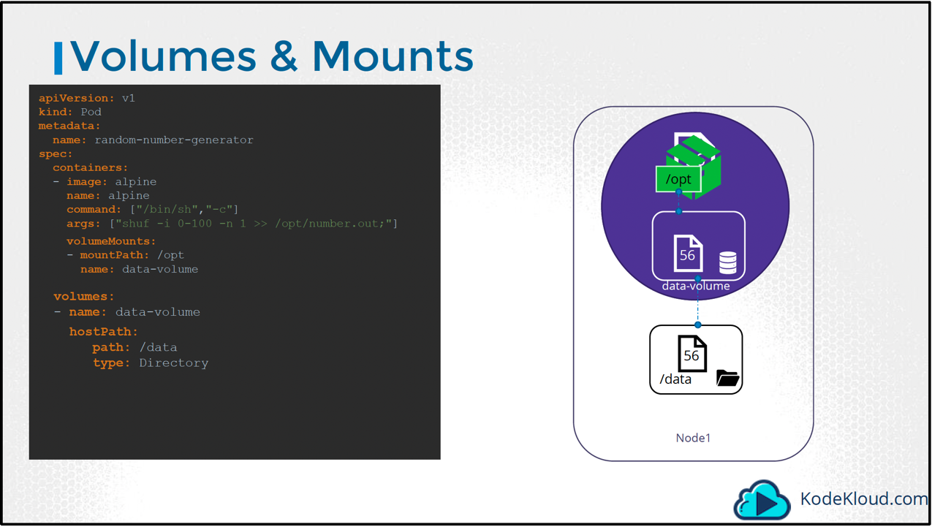

We have a single node Kubernetes cluster. We create a simple POD that generates a random between 1 and 100 and writes that to a file at /data/number.out and then gets deleted along with the random number. To retain the number generated by the pod, we create a volume. And a Volume needs a storage. When you create a volume, you can choose to configure its storage in different ways. We will look at the various options in a bit, but for now we will simply configure it to use a directory on the host. In this case I specify a path /data on the host. This way any files created in the volume would be stored in the directory data on my node.

Once the volume is created, to access it from a container we mount the volume to a directory inside the container. We use the volumeMounts field in each container to mount the data-volume to the directory /opt within the container. The random number will now be written to /opt mount inside the container, which happens to be on the data-volume which is in fact /data directory on the host. When the pod gets deleted, the file with the random number still lives on the host.

However, it is not recommended for use in a multi-node cluster. This is because the PODs would use the /data directory on all the nodes and expect all of them to be the same and have the same data. Since they are on different servers, they are in fact not the same, unless you configure some kind of external replicated clustered storage solution.

Kubernetes supports several types of standard storage solutions such as NFS, glusterFS, Flocker, FibreChannel, CephFS, ScaleIO or public cloud solutions like AWS EBS, Azure Disk or File or Google’s Persistent Disk.

For example, to configure an AWS Elastic Block Store volume as the storage or the volume, we replace hostPath field of the volume with awsElasticBlockStore field along with the volumeID and filesystem type. The Volume storage will now be on AWS EBS.

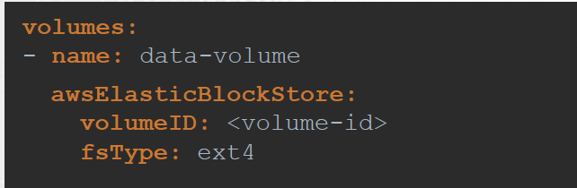

**Persistent Volumes**

Kubernetes has a number of storage types, and these can be mixed and matched within a pod. The important objects for running stateful containers are:  
**Persistent Volume** — low level representation of a storage volume.  
**Persistent Volume Claim** — binding between a Pod and Persistent Volume.  
**Storage Class** — allows for dynamic provisioning of Persistent Volumes.

**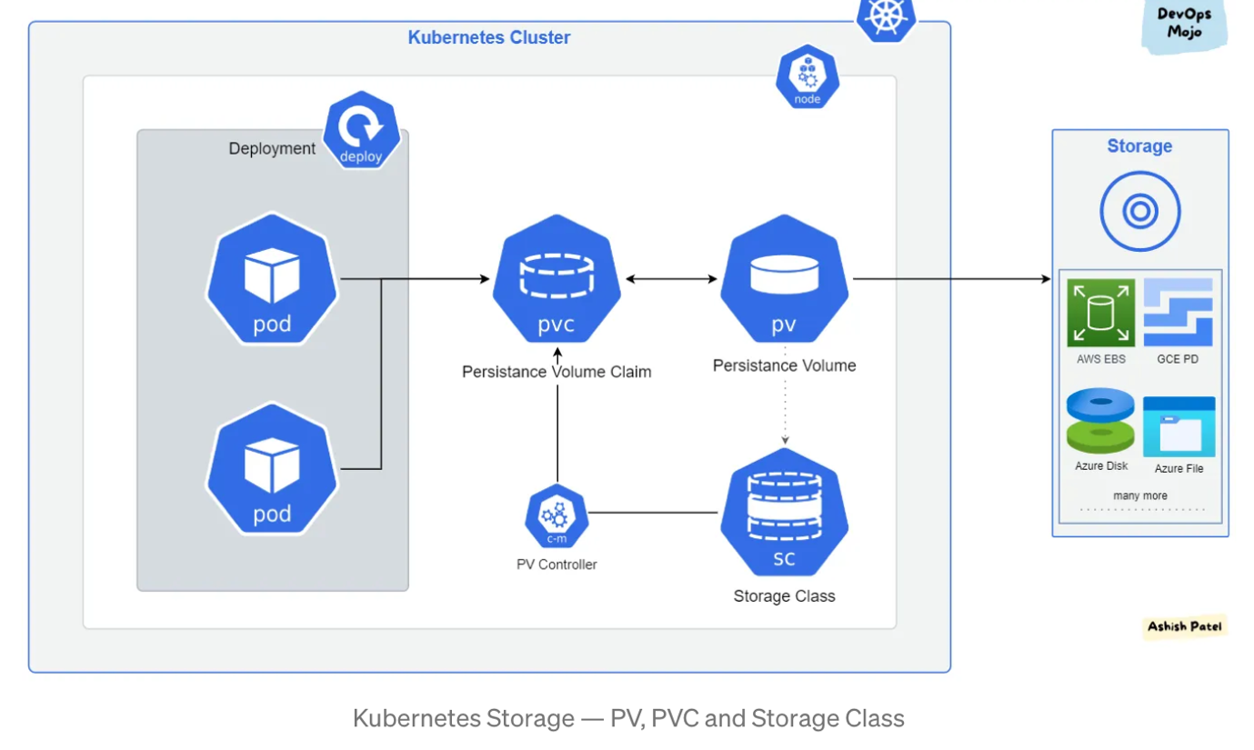**

When we created volumes in previous we configured volumes within the POD definition file. So every configuration information required to configure storage for the volume goes within the pod definition file.

When we have a large environment with a lot of users deploying a lot of PODs, the users would have to configure storage every time for each POD. Whatever storage solution is used, the user who deploys the PODs would have to configure that on all POD definition files in his environment. Every time a change is to be made, the user would have to make them on all of his PODs.

Instead, we can manage storage more centrally.

We can configure it in a way that an administrator can create a large pool of storage, and then have users carve out pieces from it as required. That is where Persistent Volumes can help us. A Persistent Volume is a Cluster wide pool of storage volumes configured by an Administrator, to be used by users deploying applications on the cluster. The users can now select storage from this pool using Persistent Volume Claims.

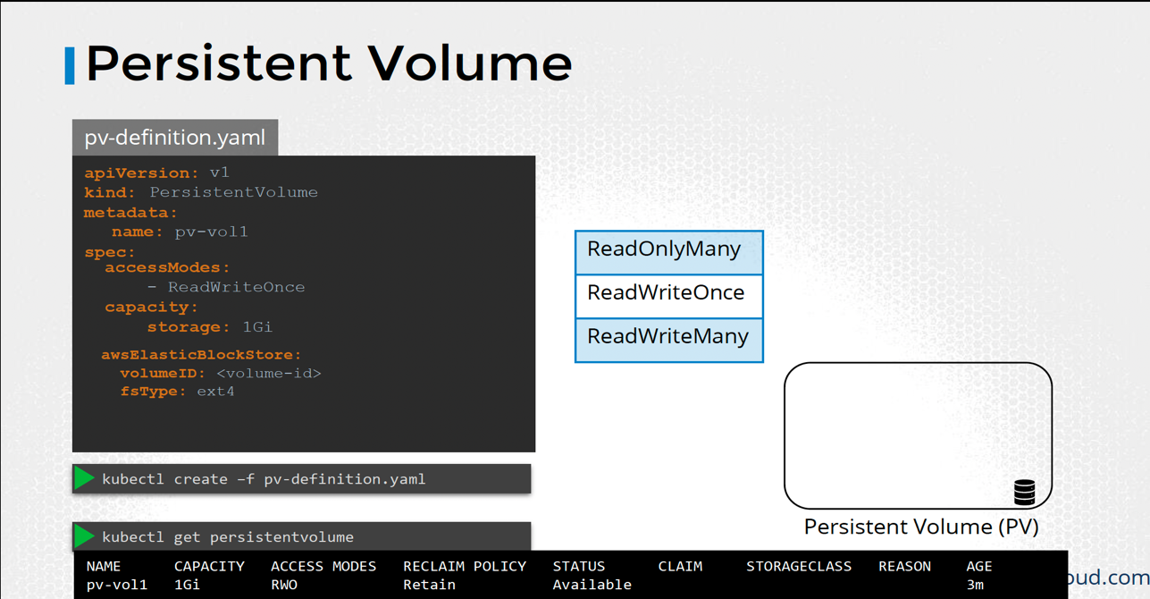

Access Mode defines how the Volume should be mounted on the hosts. Weather in a ReadOnlymode, or ReadWritemode. The supported values are

**ReadWriteOnce(RWO)** — volume can be mounted as read-write by a single node.  
**ReadOnlyMany(ROX)** — volume can be mounted read-only by many nodes.  
**ReadWriteMany(RWX)** — volume can be mounted as read-write by many nodes.  
**ReadWriteOncePod(RWOP)** — volume can be mounted as read-write by a single Pod.

Capacity is required to specify the amount of storage to be reserved for this Persistent Volume.   
Replace the hostPath option with one of the supported storage solutions.

PV is an abstraction for the physical storage device that attached to the cluster. PV is used to manage durable storage which needs actual physical storage.

PV is independent of the lifecycle of the Pods. It means that data represented by a PV continue to exist as the cluster changes and as Pods are deleted and recreated.

PV is not Namespaced, it is available to whole cluster. i.e. PV is accessible to all namespaces.

PV is resource in the cluster that can be provisioned dynamically using Storage Classes, or they can be explicitly created by a cluster administrator.  
Unlike Volumes, the PVs lifecycle is managed by Kubernetes.

apiVersion: v1

kind: PersistentVolume

metadata:

name: myapp-mongo-pv

spec:

capacity:

storage: 1Gi

volumeMode: Filesystem

accessModes:

- ReadWriteOnce

persistentVolumeReclaimPolicy: Recycle

storageClassName: myapp-sc

mountOptions:

- hard

- nfsvers=4.1

nfs:

path: /tmp

server: 172.17.0.2

**Persistant Volume Claims:**

Persistent Volumes and Persistent Volume Claims are two separate objects in the Kubernetes namespace. An Administrator creates a set of Persistent Volumes and a user creates Persistent Volume Claims to use the storage. Once the Persistent Volume Claims are created, Kubernetes binds the Persistent Volumes to Claims based on the request and properties set on the volume.  
Once the Persistent Volume Claims are created, Kubernetes binds the Persistent Volumes to Claims based on the request and properties set on the volume.  
Every Persistent Volume Claim is bound to a single Persistent volume. During the binding process, **kubernetes** tries to find a Persistent Volume that has sufficient Capacity as requested by the Claim, and any other requested properties such as Access Modes, Volume Modes, Storage Class etc.  
However, if there are multiple possible matches for a single claim, and you would like to specifically use a particular Volume, you could still use labels and selectors to bind to the right volumes.  
Finally, note that a smaller Claim may get bound to a larger volume if all the other criteria matches and there are no better options. There is a one-to-one relationship between Claims and Volumes, so no other claim can utilize the remaining capacity in the volume. If there are no volumes available the Persistent Volume Claim will remain in a pending state, until newer volumes are made available to the cluster. Once newer volumes are available the claim would automatically be bound to the newly available volume.

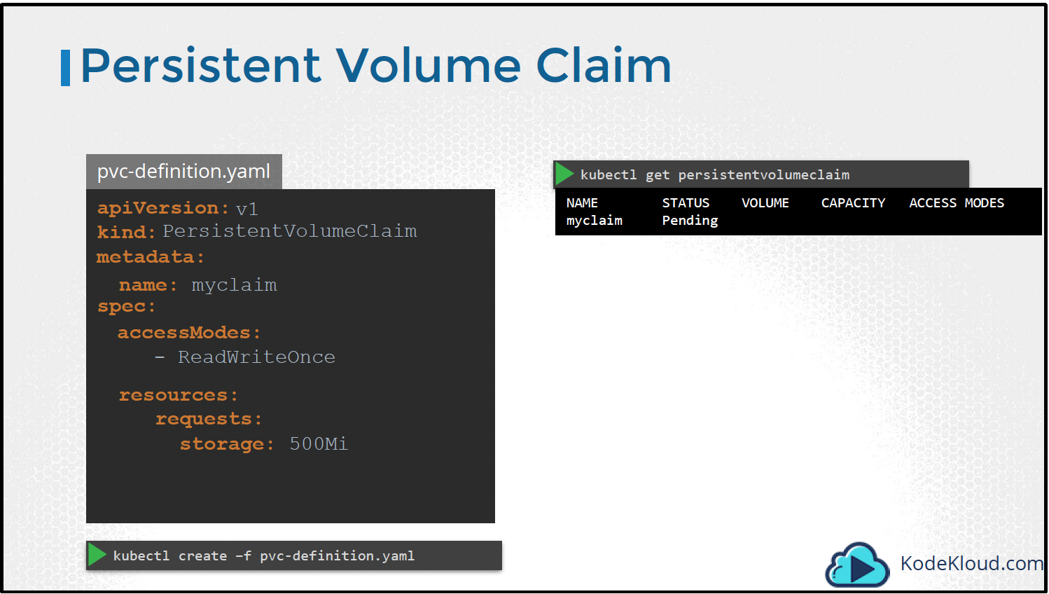

Under specification set the accessModes to ReadWriteOnce. And set resources to request a storage of 500 megabytes. To view the created claim run the kubectl get persistentvolumeclaim/pvc. We see the claim in a pending state.

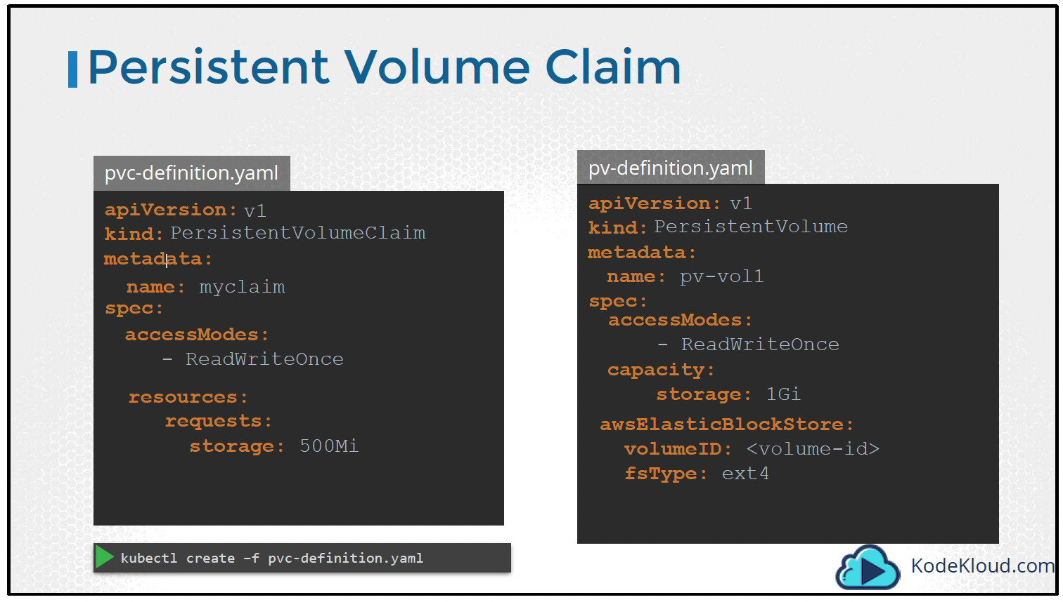

When the claim is created, kubernetes looks at the volume created previously. The access Modes match. The capacity requested is 500 Megabytes but the volume is configured with 1 GB of storage. Since there are no other volumes available, the PVC is bound to the PV.

To delete a PVC run the kubectldelete persistentvolumeclaimcommand. But happens to the Underlying Persistent Volume when the claim is deleted? You can chose what is to happen to the volume. By default, it is set to Retain. Meaning the Persistent Volume will remain until it is manually deleted by the administrator. It is not available for re-use by any other claims. Or it can be Deleted automatically. This way as soon as the claim is deleted, the volume will be deleted as well. Or a third option is to recycle. In this case the data in the volume will be scrubbed before making it available to other claims.

**persistentVolumeReclaimPolicy:** Retain/Delete/Recycle

PVC is binding between a Pod and PV. Pod request the Volume through the PVC.

PVC is the request to provision persistent storage with a specific type and configuration.

PVC is similar to a Pod. Pods consume node resources and PVC consume PV resources.

Kubernetes looks for a PV that meets the criteria defined in the PVC, and if there is one, it matches claim to PV.

PVCs describe the storage capacity and characteristics a pod requires, and the cluster attempts to match the request and provision the desired persistent volume.

PVC must be in same namespace as the Pod. For each Pod, a PVC makes a storage consumption request within a namespace.

Claims can request specific size and access modes (e.g., they can be mounted ReadWriteOnce, ReadOnlyMany or ReadWriteMany).

PVC to PV binding is a one-to-one mapping. The process uses a ClaimRef, which creates a bi-directional binding between PV and PVC.

apiVersion: v1

kind: PersistentVolumeClaim

metadata:

name: myapp-mongo-pvc

spec:

resources:

requests:

storage: 500Mi

volumeMode: Filesystem

accessModes:

- ReadWriteOnce

# **Storage Classes (SC)**

If we use google storage then every time we create any pv, before that we have to google cloud storage and we have to give the same name of the google cloud storage to the pdName under gmePersistantDisk under spec section of PersistantVolume. That’s why we call it static provisioning. In Storage class we can define provisioner like google cloud that can create storage automatically and attach to pod when claim is made.  
Once we make any StorageClass then we don’t need any PV because PV is made automatically. To use a storageClass we use storageClassName key under spec section of persistent volume claim.

apiVersion: storage.k8s.io/v1

kind: StorageClass

metadata:

name: myapp-sc

provisioner: kubernetes.io/aws-ebs

reclaimPolicy: Retain

volumeBindingMode: WaitForFirstConsumer

parameters:

type: io1

iopsPerGB: "10"

fsType: ext4

StorageClass allows dynamic provisioning of Persistent Volumes, when PVC claims it.

StorageClass abstracts underlying storage provider.

StorageClass is used in conjunction with PVC that allow Pods to dynamically request a new storage.

StorageClass use provisioners that are specific to the storage platform or cloud provider to give Kubernetes access to the physical storage.

Each storage backend has own provisioner. Storage Backend is defined in the StorageClass component via provisioner attribute.

## Reclaim Policy

PV that are dynamically created by a StorageClass will have the reclaim policy specified in the reclaimPolicy field of the class, which can be either Delete or Retain.

If no reclaimPolicy is specified when a StorageClass object is created, it will default to Delete.

PV that are created manually and managed via a StorageClass will have whatever reclaim policy they were assigned at creation.

The reclaim policy applies to the persistent volumes not to the storage class itself. PVs and PVCs that are created using that StorageClass will inherit the reclaim policy set in StorageClass.

**StatefulSet**

Before deploying an application to production, we should know the underlying architecture of the application. A term used in this context is that the application is “Stateless” or “Stateful”.

Stateless applications do not keep the record of the previous state, or each request is completely new. The only thing cluster is responsible for static content hosted on it. Stateless application has no persistent storage attached to it. Different pods across the cluster can work independently.

On the other hand, examples of Stateful Applications are databases hosted on the K8s. Pods have persistent volumes(PV) attached to them, and data replication among pods has to take place periodically.

Both Stateful and Stateless applications are deployed using different components of K8s, Stateless applications are deployed using deployment component, and Stateful applications are deployed using StatefulSet component.

# Why different components for different types of applications?

Just like the deployment component Stateful set component also helps us to replicate the pods. Both components even allow us to connect storage the same way, but what is the difference then?

Deployment creates identical replica pods; pods are created in random order with random postfix hash. For example, IDs of different replicas are “**my-backend-98fxc30e”, “my-backend-78qwefg”,**etc., and if we scale down, then the random pod is picked and deleted. Replicas are chosen randomly for the handling of the request.

In StatefulSet, replicas can’t be deleted at the same time; pods can’t be randomly addressed as replica pods are not identical. In a stateful set, pods get ID in increasing order, and this ID sticks with the pod. If, in any case, one of the pod dies the newly generated pod will be of the same ID. Examples of replicas are**“Mongo-0”**, “**Mongo-1”, “Mongo-2” … “Mongo-8”,**and if we scale down, then first the last pod is removed, which in this case is Mongo-8, then further pods are deleted.

# **Why we need StatefulSet and its features?**

Let us consider an example in which we have MongoDB running in a pod. In this, we have pre-defined that the only master can read and write to its own volume, and the other slave nodes will copy from the master’s PV and then through slave nodes, only read operations can be done. If we allow writing operations from the slave pod, then data inconsistency will occur.

Each replica will have its own PV, and continuous data synchronization between master and slaves is done So that the new read request will get the most updated data from the slave nodes. For example, if the scaling operation is applied to the pod, then all of its predecessors must be running, and once the new pod is ready, it will replicate data from the first N-1 pod. If Mongo-4 is ready, then it will synchronise data from Mongo-3.

The use of this sequential ID is when any of the pod dies or restarts, the new pod can retain state and can retain role(master, slave). In StatefulSet, if pods are being deleted, they are deleted in reverse order, from{N-1..0}.

Kubernetes docker is not perfect for stateful applications. If we want to host a database in Kubernetes, we have to work for configuring the cloning and data synchronization, managing and backup. Because of these challenges, we can choose cloud-hosted database services that will handle all these challenges for us.

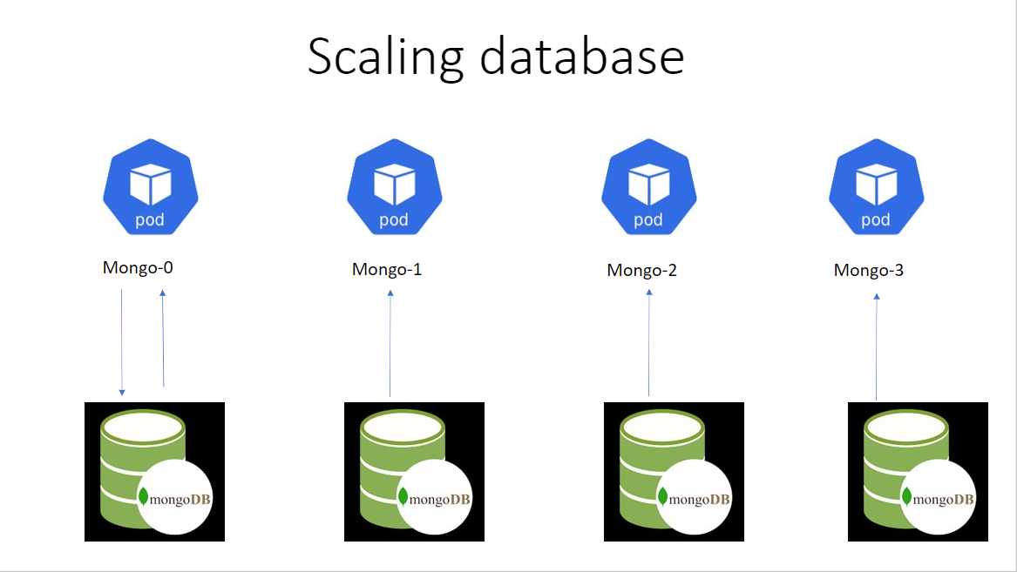

apiVersion: apps/v1

kind: StatefulSet

metadata:

name: web

spec:

selector:

matchLabels:

app: nginx

serviceName: "nginx"

replicas: 3

minReadySeconds: 10

template:

metadata:

labels:

app: nginx

spec:

terminationGracePeriodSeconds: 10

containers:

- name: nginx

image: nginx

ports:

- containerPort: 80

name: web

volumeMounts:

- name: www

mountPath: /usr/share/nginx/html

volumes:

- name: www

hostPath:

path: /data/nginx/html

type: DirectoryOrCreate

apiVersion: apps/v1

kind: StatefulSet

metadata:

name: myapp-mongodb-sts

namespace: myapp-ns

labels:

app: myapp-mongodb

spec:

selector:

matchLabels:

app: mongodb

serviceName: mongodb

replicas: 2

template:

metadata:

labels:

app: myapp-mongodb

spec:

containers:

- name: myapp-mongodb

image: mongo

imagePullPolicy: IfNotPresent

ports:

- containerPort: 27017

name: mongodb

volumeMounts:

- name: myapp-mongo-volume

mountPath: /var/lib/mongodb

volumes:

- name: myapp-mongo-volume

persistentVolumeClaim:

claimName: myapp-mongo-pvc

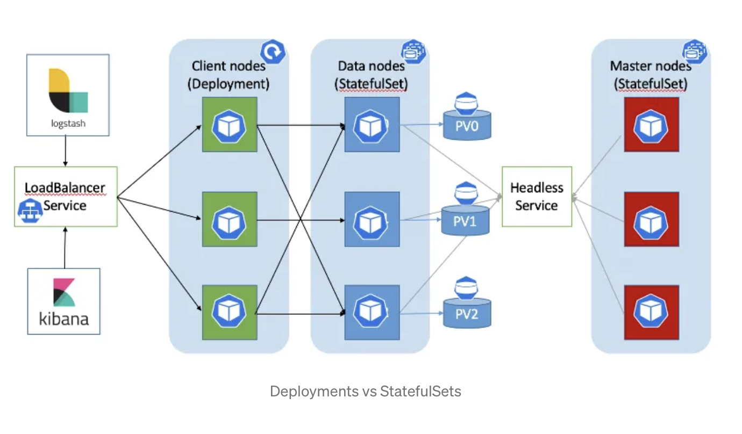

If we don’t want to use the same volume for all the pods of a statefullset. So, all the pods will have its own PVC and corresponding PVs. We can achieve the same using the **volumeClaimTemplate** field under spec section of statefullSet. The whole PVC will be under the **volumeClaimTemplate** where one **storageClass** will be mentioned and dynamically one pvc and pv will be generated per pod in the statefullset.

Deployments are usually used for stateless applications while StatefulSets are used for stateful applications.

**Key Differences**

**Pods:**Pods deployed by Deployment are identical and interchangeable, created in random order with random hashes in their Pod names.  
In contrast to that, the Pods deployed by StatefulSet component are NOT identical. They each have their own sticky identity, which they keep between restarts and each can be addressed individually. Thus, they can’t be created or deleted at the same time.

**ReplicaSet:**StatefulSet is also a Controller but unlike Deployments, it doesn’t create ReplicaSet rather itself creates the Pod with a unique naming convention. It manages the deployment and scaling of a set of Pods, *and provides guarantees about the ordering and uniqueness* of these Pods.

**PVC:**Every replica of a StatefulSet will have its own state, and each of the pods will be creating its own PVC (Persistent Volume Claim). So StatefulSet with 3 replicas will create 3 pods, each having its own Volume, so total 3 PVCs.

**Rollback:**Unlike Deployments, you cannot roll back to any previous version of a StatefulSet as it don’t create ReplicaSet or anything of that sort. You can only delete or scale up/down the Statefulset.

**States:**To save the states StatefulSets use volumeClaimTemplates/claims of persistent volumes in order to keep the state safe in case of crashes or restarts.

# **Headless Services**

It’s a service without loadbalancer in case of multiple pods & gives unique Identifier to pod as identification.

Example -: In case of MySQL DB . We know we point one app to another through service ,suppose we have a My-sql db 3 pods cluster & webapp want to connect to the DB but a service will act as loadbalancer ,can read write from any DB, but in production setup only master DB should be used by application to write data ,other pods/slave dbs can be used for reading the data also when a pod dies a new pod is created as replica-set than dns /Ip will change so we cannot force application to write only to master .In this scenario headless service will be used ,which results in a unique dns creation so one pod can be used to write data.

Also we need to only mention **ClusterIP : None** to make headless service. see below example.

apiVersion: v1

kind: Service

metadata:

name: mysql

labels:

app: mysql

app.kubernetes.io/name: mysql

spec:

ports:

- name: mysql

port: 3306

**clusterIP: None**

selector:

app: mysql

StatefullSet using Headless Service-: Creates automatic domain Name & subdomains/A-record.

mysql-0-mysql-h.default.svc.cluster.local [we can use this as Master DB]

mysql-1-mysql-h.default.svc.cluster.local

mysql-2-mysql-h.default.svc.cluster.local

apiVersion: apps/v1

kind: StatefulSet

metadata:

name: mysql

spec:

selector:

matchLabels:

app: mysql

app.kubernetes.io/name: mysql

**serviceName: mysql**

replicas: 3

template:

metadata:

labels:

app: mysql

app.kubernetes.io/name: mysql

**Admin related things**

**To get all curl into kube-system**

kubectl proxy --port=8080  
curl <http://localhost:8080/apis>

**To exec into minikube node**

minikube ssh

**To port forward a service**

kubectl port-forward svc/mongo-svc 32000:27017

**EmptyDir**

**Ephemeral Volumes vs Persistent Volumes**

# **What is Ephemeral Volumes**

Ephemeral volumes are designed for Pods that do not require persistent data. For example, sometimes your application Pods just need additional data but don’t care whether that data is stored and don’t require data to be persist across container restarts (**transient applications**), such as secret keys and configuration data.

K8s use ephemeral volumes to achieve this kind of storage needs. It allows Pods to be started and stopped without being limited to the location of persistent volume. In addition to this, pods in K8s leverage ephemeral storage for functions such as caching, scratch space, and logs.

Ephemeral storage is also considered crucial for sharing nonessential data within multi-container pods and injecting configuration data into a pod.

Ephemeral volumes are specified inline in the Pod spec, in order to simplify application deployment and management.

K8s supports the following different kinds of ephemeral volumes:

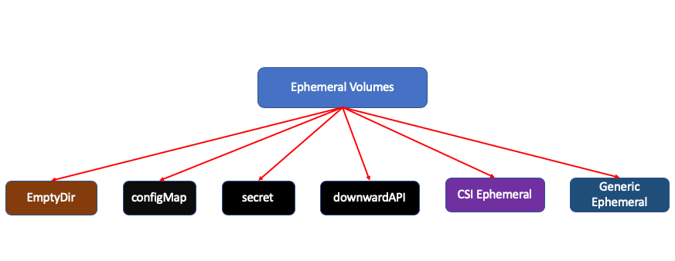

Below is one example of Ephemeral volume specification:

kind: Pod

apiVersion: v1

metadata:

name: busybox

spec:

containers:

- name: busybox

image: busybox

volumeMounts:

- mountPath: "/data"

name: data-volume

volumes:

- name: data-volume

ephemeral:

volumeClaimTemplate:

metadata:

labels:

type: busybox

spec:

accessModes: [ "ReadWriteMany" ]

storageClassName: "data-storage-class"

resources:

requests:

storage: 1Gi

## Local ephemeral storage

Local ephemeral storage are backed by locally-attached writeable devices or RAM.

emptyDir, configMap, downwardAPI, secret volumes are provided as local ephemeral storage. **They are provisioned as local ephemeral storage and managed by kubelet on each node**.

The following screenshot shows you that configMap , secret and emptyDir are all mounted locally and managed by kubelet :

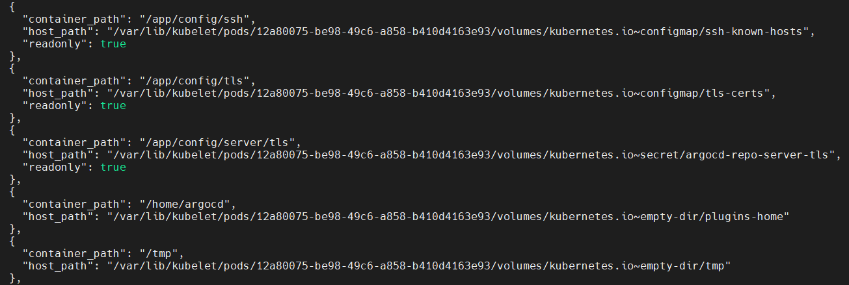

## ****Generic ephemeral volumes****

These volumes can be provisioned using any storage driver that supports the dynamic provisioning of persistent volumes. These volumes provide a **pod-level** directory for scratch data that is discarded after provisioning. Some features of generic ephemeral volumes include:

Supports both local and network-attached storage

Supports size restrictions for pods

Depending on parameters and the storage driver used, these volumes may contain some initial data

Depending on the storage driver used, generic ephemeral volumes may implement snapshotting, cloning, storage capacity tracking and resizing

**kind**: Pod

**apiVersion**: v1

**metadata**:

**name**: my-app

**spec**:

**containers**:

- **name**: my-frontend

**image**: busybox:1.28

**volumeMounts**:

- **mountPath**: "/scratch"

**name**: scratch-volume

**command**: [ "sleep", "1000000" ]

**volumes**:

- **name**: scratch-volume

**ephemeral**:

**volumeClaimTemplate**:

**metadata**:

**labels**:

**type**: my-frontend-volume

**spec**:

**accessModes**: [ "ReadWriteOnce" ]

**storageClassName**: "scratch-storage-class"

**resources**:

**requests**:

**storage**: 1Gi

## ****CSI ephemeral volumes****

These volumes are provisioned by third-party Container Storage Interface (CSI) drivers. It allows users to provide volumeAttributes directly to the CSI driver as part of the Pod spec.

**kind**: Pod

**apiVersion**: v1

**metadata**:

**name**: my-app

**spec**:

**containers**:

- **name**: my-frontend

**image**: busybox:1.28

**volumeMounts**:

- **mountPath**: "/scratch"

**name**: scratch-volume

**command**: [ "sleep", "1000000" ]

**volumes**:

- **name**: scratch-volume

**ephemeral**:

**volumeClaimTemplate**:

**metadata**:

**labels**:

**type**: my-frontend-volume

**spec**:

**accessModes**: [ "ReadWriteOnce" ]

**storageClassName**: "scratch-storage-class"

**resources**:

**requests**:

**storage**: 1Gi

# **Ephemeral Storage Options**

Ephemeral storage is hosted in an unstructured volume that is shared between the container runtime, the operating system, and all pods running in the node.

The volumes prevent these entities from using the node’s local storage excessively. **Ephemeral storage is always hosted on the local storage’s primary partition.** There are two ways of creating this partition:

## Root

The root partition holds the logs (/var/log) and kubelet (/var/lib/kubelet) directories and is shared among K8s system daemons, user pods, and the underlying operating system. With such a setup, pods use EmptyDir volumes to consume ephemeral storage in the root primary partition.

Pods also utilize the root partition when creating image layers, container-writeable layers, and container logs for transient applications. A root partition is completely ephemeral, so it doesn’t support any performance SLAs, such as disk IOPS.

## ****Runtime****

The runtime partition is an optional ephemeral storage that container runtimes can use to implement overlay file systems. When implementing isolation for the partition, runtime then provides shared access.

This partition stores container-writable layers and image layers. Once the runtime partition is created, these layers are written onto it by default and not the root partition.

# **How to Pass a Configuration File to a Kubernetes Pod**

Kubernetes is a system that helps manage containerized applications. It can help you scale your applications and make sure that they are running smoothly. You can even use Kubernetes to improve the way you manage and deploy data science projects.

One issue you may encounter while using Kubernetes is how to pass a configuration file to a pod at runtime. For example, your pod contains a service that connects to an external service through some credentials, which are stored in a file

The problem is that you want to save the configuration file to Pod 1 at run time, without rebuilding the image each time.

# **What a ConfigMap is in Kubernetes**

ConfigMap is a Kubernetes resource that allows you to decouple environment-specific configuration data from your container images.

This ensures that your application can be easily moved between environments without having to rebuild your container image.

Additionally, using a ConfigMap can help you avoid hard-coding sensitive information in your container image, such as database passwords.

You can define your own ConfigMap in a .yaml file as follows:

apiVersion: v1

kind: ConfigMap

metadata:

name: my-config-map

data:

key1 : value1

key2 : value2

# **How to use a ConfigMap to pass a Configuration file to a pod**

You can use a ConfigMap to store an entire configuration file, which can be mounted as a file in your pod. You can proceed as follows.

Firstly, you add the configuration file to your ConfigMap .yaml file:  
In the example, we have added file.conf, which can store all the parameters needed to connect to Service B.  
Now, you can use the ConfigMap within your deployment, as follows.

**apiVersion**: v1

**kind**: Deployment

**metadata**:

**name**: my-deployment

**spec**:

**containers**:

...

**volumeMounts**:

- **name**: config

**mountPath**: "path/ to/mount/the/file"

**subPath**: file.conf

**volumes**:

- **name**: config

**configMap**:

**name**: my-config-map

**items**:

- **key**: "file.conf"

**path**: "file.conf"

**apiVersion**: v1

**kind**: ConfigMap

**metadata**:

**name**: my-config-map

**data**:

**file.conf**: |

param1=value1

param2=value2

paramN=valueN

In the volumeMounts section, we specify the path within the pod where to mount the file. We can also specify the subPath, which includes just the file to mount. If we omit this part, we can mount the whole directory.

In the volumes section, we specify the details of ConfigMap use. The key identifies the name in the ConfigMap and the path the name of the file to create in the pod.

# **What a secret is in Kubernetes**

A Secret in Kubernetes is an object that contains sensitive information such as passwords, API keys, and certificates. Secrets are used to store and manage this sensitive information.

Secrets are encrypted and can only be decrypted by the pods that need to use them. This ensures that only the pods that need to access the sensitive information can do so. Secrets are an important part of keeping your Kubernetes cluster secure.

Kubernetes secrets consume encrypted values, that you can create in a command-line terminal, as follows:

**echo** -n "my\_secret" | **base64**

Then, you can copy the result of the previous operation in the .yaml file storing your secrets. You can define your own Secret in a .yaml file as follows:

**apiVersion**: v1

**data**:

**username**: my\_encoded\_username

**password**: my\_encoded\_password

**kind**: Secret

**metadata**:

**name**: my\_secret

**type**: Opaque

# How to use a **Secret** to pass a configuration file to a pod

It may happen that the configuration file to pass to the pod contains some sensible information, such as username and password. In this case, you cannot use a ConfigMap to store data. Instead, you can use a Secret.

The principle is the same as the ConfigMap: firstly you store the entire configuration file as a secret, then you mount it as a volume in the pod.

You can notice that the password is not encrypted. However, when you create the secret, Kubernetes will encrypt it for you and it will distributed it as an encrypted object.  
When you want to use the secret in a deployment, you proceed as follows:

**apiVersion**: v1

**kind**: Deployment

**metadata**:

**name**: my-deployment

**spec**:

**containers**:

...

**volumeMounts**:

- **name**: secret-file

**mountPath**: "path/ to/mount/the/file"

**subPath**: file.conf

**volumes**:

- **name**: secret-file

**secret**:

**secretName**: my\_secret

---

**apiVersion**: v1

**stringData**:

**file.conf**: |-

username=demo

password=plain\_password

**kind**: Secret

**metadata**:

**name**: my\_secret

**type**: Opaque

# **What is Ephemeral Container?**

In K8s, an ephemeral container is a temporary container that can be added to an existing pod to perform a specific task, such as debugging, monitoring, or troubleshooting. Unlike regular containers, ephemeral containers **do not persist** beyond their immediate use, and they are not part of the pod’s desired state.

Ephemeral containers are useful for interactive troubleshooting when kubectl exec is insufficient because a container has crashed or a container image doesn't include debugging utilities. For example, when you want to use kubectl exec to create a shell in a container image that has no shell utility:

$ kubectl exec -it my-demo -- sh  
OCI runtime exec failed: exec failed: container\_linux.go:346: starting container process caused "exec: \"sh\": executable file not found in $PATH": unknown

You can instead add a debugging container using kubectl debug. If you specify the -i/--interactive argument, kubectl will automatically attach to the console of the Ephemeral Container.

$ kubectl debug -it my-demo --image=busybox --target=my-demo

Ephemeral containers differ from other containers in that they lack guarantees for resources or execution, and they will never be automatically restarted, so they are not appropriate for building applications. Ephemeral containers are described using the same ContainerSpec as regular containers, but many fields are incompatible and disallowed for ephemeral containers. For example:

* Ephemeral containers may not have ports, so fields such as ports, livenessProbe, readinessProbe are disallowed.
* Pod resource allocations are immutable, so setting resources is disallowed.

***Ephemeral containers are created using a special ephemeralcontainers handler in the API rather than by adding them directly to pod.spec, so it's not possible to add an ephemeral container using kubectl edit.***

# Ephemeral Container Usage

Ephemeral containers are useful for interactive troubleshooting when kubectl exec is insufficient because a container has crashed or a container image doesn't include debugging utilities.

Below are some examples of how ephemeral containers can be used in K8s:

## Troubleshooting or Debugging

Ephemeral containers can be used to debug an application running in a pod by providing an interactive shell or running a specific debugging tool. This can help developers troubleshoot issues without having to recreate the pod or modify the original container.

Let’s say you have a pod running a container named my-app and you want to debug an issue with the container. You can create an ephemeral container with a shell to inspect the container's environment and run diagnostic commands. Here are the steps:

*Note, the debug feature gate needs to be enabled. You can do this by adding --feature-gates=DebugContainers=true to the kubelet and kube-apiserver configuration.*

Run the following command to create an ephemeral container:

$ kubectl debug <pod-name> -it --image=busybox -- sh

Once the ephemeral container is created, you will be presented with a shell prompt. You can run diagnostic commands, inspect the container’s environment, or modify the container’s configuration to debug the issue.

## Log collection

Ephemeral containers can be used to collect logs from a running container or to run a log analysis tool. This can help operators diagnose issues and monitor the performance of an application.

For example, first let’s create a Pod with an ephemeral container.

apiVersion: v1

kind: Pod

metadata:

name: ephemeral-container-example

spec:

containers:

- name: main-container

image: nginx

ports:

- containerPort: 80

ephemeralContainers:

- name: debug-container

image: busybox

command: ["/bin/sh"]

args: ["-c", "sleep 3600"]

This Pod has two containers: main-container with an nginx image and debug-container with a busybox image. The debug-container is an ephemeral container that runs a sleep command for an hour.

After deployment, if you run kubectl describe pod command, the output will include a section on ephemeral containers, which should look something like this:

Ephemeral Containers:

debug-container:

Image: busybox

Command: /bin/sh

Args:

-c

sleep 3600

Port: <none>

Host Port: <none>

Environment: <none>

Mounts:

<none>

To collect logs from the ephemeral container, use the following command:

$ kubectl logs ephemeral-container-example -c debug-container

**Security scanning**

Ephemeral containers can be used to run a security scanning tool to check the pod or container for vulnerabilities or potential security issues.

First of all, you need to make sure you have a security scanner installed in your K8s cluster. There are several open-source and commercial options available, such as Anchore, Aqua Security, and Sysdig Secure. Assuming we use the Anchore scanner.

Now create a Pod with an ephemeral container that includes the security scanner. The YAML file looks like:

apiVersion: v1

kind: Pod

metadata:

name: ephemeral-container-security-scanning

spec:

containers:

- name: main-container

image: nginx

ports:

- containerPort: 80

ephemeralContainers:

- name: security-scanner

image: docker.io/anchore/anchore-engine:v0.9.1

imagePullPolicy: IfNotPresent

command: ["anchore-manager"]

args:

- --debug

- --policy-path

- /config/policy.yaml

volumeMounts:

- name: config

mountPath: /config

volumes:

- name: config

configMap:

name: security-scanner-config

Once the Pod is running, check the logs of the security-scanner ephemeral container to see the scan results:

$ kubectl logs ephemeral-container-security-scanning -c security-scanner

**Backup and restore**

Ephemeral containers can be used to perform backup and restore operations on data stored in a pod or container. This can help operators recover from data loss or corruption.

One example will look like:

apiVersion: v1

kind: Pod

metadata:

name: ephemeral-container-backup-restore

spec:

containers:

- name: main-container

image: nginx

volumeMounts:

- name: data

mountPath: /data

ephemeralContainers:

- name: backup-container

image: busybox

command: ["/bin/sh"]

args: ["-c", "tar -czvf /backup/data.tar.gz /data"]

volumeMounts:

- name: data

mountPath: /data

- name: backup

mountPath: /backup

- name: restore-container

image: busybox

command: ["/bin/sh"]

args: ["-c", "tar -xzvf /restore/data.tar.gz -C /"]

volumeMounts:

- name: data

mountPath: /data

- name: restore

mountPath: /restore

volumes:

- name: data

emptyDir: {}

- name: backup

emptyDir: {}

- name: restore

emptyDir: {}

As you can see from the above YAML file, the backup-container creates a tarball of the /data directory and stores it in a volume named backup. The restore-container restores the tarball from the backup volume to the /data directory. Once the Pod has been created, we can verify that the data backup/restore works by:

$ kubectl exec ephemeral-container-backup-restore -c backup-container -- tar -tzvf /backup/data.tar.gz  
$ kubectl exec ephemeral-container-backup-restore -c restore-container -- ls /data

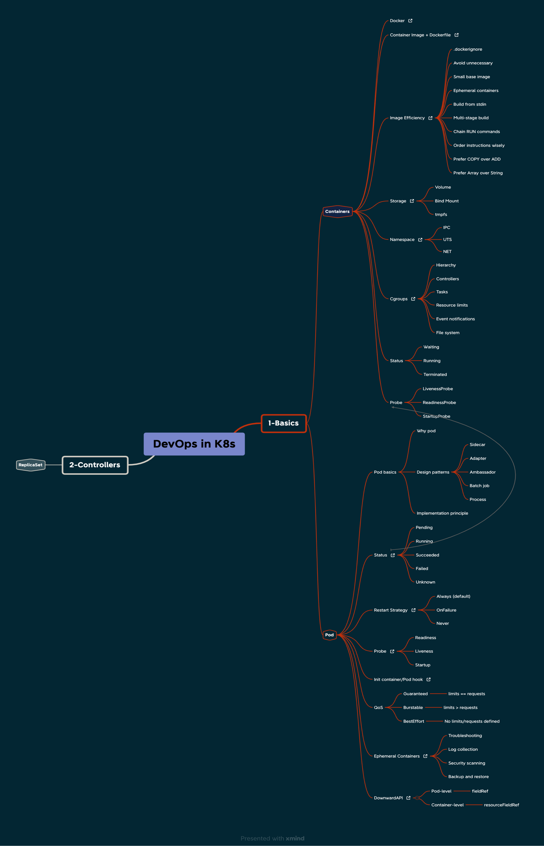

# **Implementing Network Segmentation in Kubernetes Clusters**

A computer network is segmented into smaller subnetworks or segments to increase performance and security. This can also be used to isolate network traffic to particular segments to ease congestion and enhance overall network performance. Segments can also be used to limit the scope of security breaches in a network.

The deployment, scaling, and maintenance of containerized applications are automated using the open-source container orchestration technology known as Kubernetes (also known as K8s). The simplicity with which one can divide and isolate various components of a workload or application within a network is one of the main advantages of adopting Kubernetes. Pods — logical host units that house one or more containers — are used to achieve this. A Kubernetes cluster’s [nodes](https://kubernetes.io/docs/concepts/architecture/nodes/) can be used to deploy pods, and network policies can be used to segregate individual pods from one another.

A highly secure and scalable environment can be produced to execute containerized applications by combining network segmentation and Kubernetes. Within a Kubernetes cluster, network segmentation can be used to divide up an application or workload into distinct sections, and Kubernetes offers the infrastructure and management capabilities required to coordinate and control these separate parts. As a result, security may be enhanced, the chance of data breaches decreased, and applications may be able to operate as efficiently as possible.

# **What is Network Segmentation and How Does It Work?**

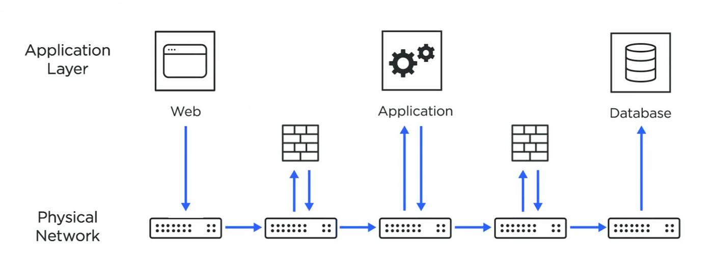

By separating a network into smaller subnetworks or segments, network segmentation improves network security and performance. It is feasible to isolate network traffic to particular segments to minimize congestion and improve overall security. For example, sensitive devices can be added to a different network segmentation that might have further authentication or firewall.

Network segmentation in Kubernetes is accomplished through the use of [pods](https://kubernetes.io/docs/concepts/workloads/pods/) and network policies. Pods are logical host units that can be deployed to particular nodes in a Kubernetes cluster and contain one or more containers. Network policies specify guidelines for how pods are permitted to communicate with one another and other cluster resources.

To increase security and prevent unauthorized access to sensitive data, a network policy can be used to restrict access to a database pod from a front-end application pod. Using network policies, a Kubernetes cluster may segregate various environments, such as the development, staging, and production environments.

Network segmentation is critical for maintaining security and optimal performance when executing containerized apps in Kubernetes. A highly secure and scalable environment for executing containerized applications can be created by employing network policies to regulate communication between pods and other resources within the cluster.

# **Benefits of Using Network Segmentation in Kubernetes Clusters**

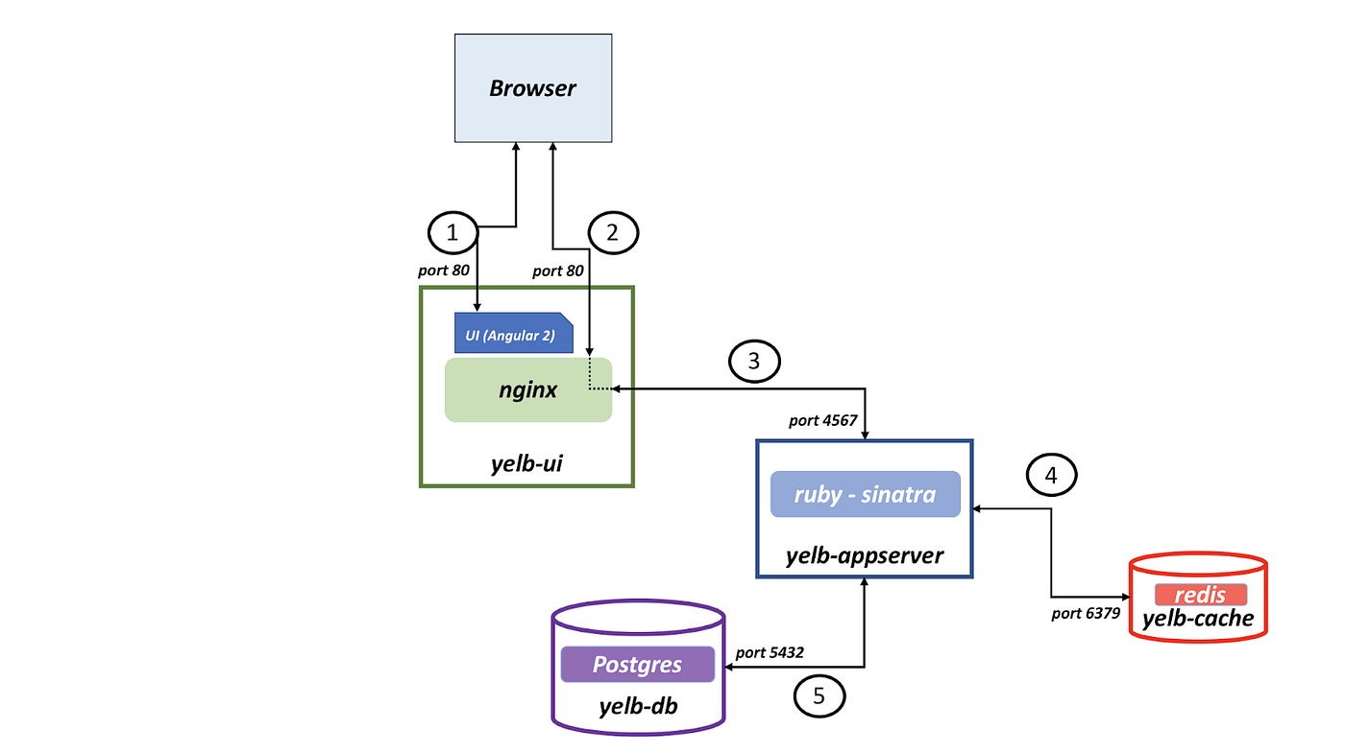

Kubernetes’ network segmentation feature makes it possible to isolate various network components, such as distinct levels of a [multi-tier](https://www.techopedia.com/definition/23599/multi-tier-application) application or sensitive data. Lowering the attack surface and limiting the potential damage from a successful attack can increase security. Let’s discuss the benefits in greater depth.

# **Improved Security**

By isolating different parts of an application or workload within a network, it is possible to limit the scope of security breaches and reduce the risk of data loss or unauthorized access. Network segmentation can prevent attackers from moving laterally within a network and accessing sensitive data or resources. As the most sensitive devices might have a firewall, further authentication methods or IP whitelisting will ensure only specific users have access to the application.

# **Enhanced Performance**

Network segmentation can reduce congestion and improve overall network performance by isolating traffic to specific segments. This can be especially beneficial when running large or resource-intensive applications, as it can help ensure that these applications have access to the resources they need to perform at their best. In addition, since the network is already divided into different parts, only specific parts will have traffic and other parts will not, which will directly improve the performance.

# **Simplified Management**

Network segmentation can make it easier to manage and maintain a Kubernetes cluster, as it can reduce the complexity of the overall system. By isolating different parts of an application or workload within a network, you will be able to identify and troubleshoot issues and make changes to specific parts of the system without impacting the entire cluster and more easily.

# **Integrating Network Segmentation with Armo Platform**

[Armo Platform](https://cloud.armosec.io/) allows for accurate visualization and analysis within the Kubernetes environment. It provides access to risk analysis, security compliance, RBAC visualization, and image vulnerability screening through a single point of entry. The Kubernetes clusters, YAML files, and Helm charts are all scanned by the Platform. It does this by checking the configurations against several different frameworks.

To properly install this and run the configuration scanning, you just need to run the following commands. We start be using the following command to deploy it:

*curl -s*[*https://raw.githubusercontent.com/kubescape/kubescape/master/install.sh*](https://raw.githubusercontent.com/kubescape/kubescape/master/install.sh)*| /bin/bash*

You can run the following command to run the scanning on the whole infrastructure.

*kubescape scan — account=1377bb62–2273–4007-a80d-cc808b88595b*

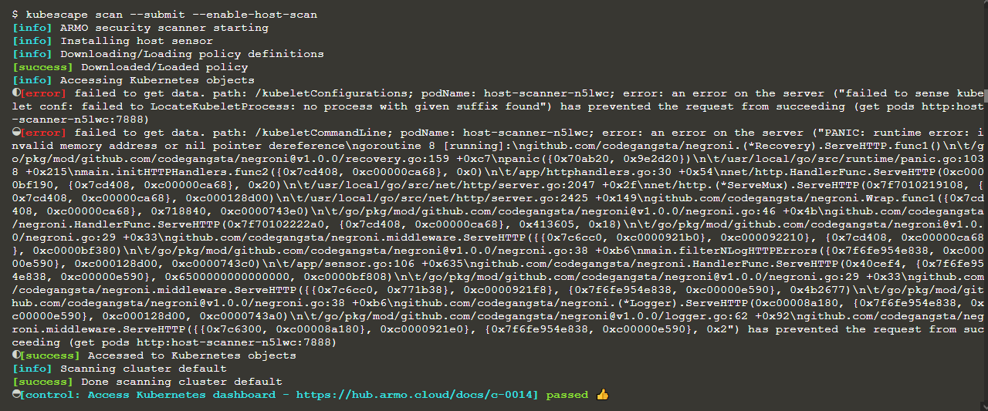

When the scanning process is over, all of the data will be sent to the cloud platform, and from there, you will be able to accurately visualise the clusters. This includes the implementation of RBAC, which means you will be able to determine which people have which kinds of permissions or authorization.

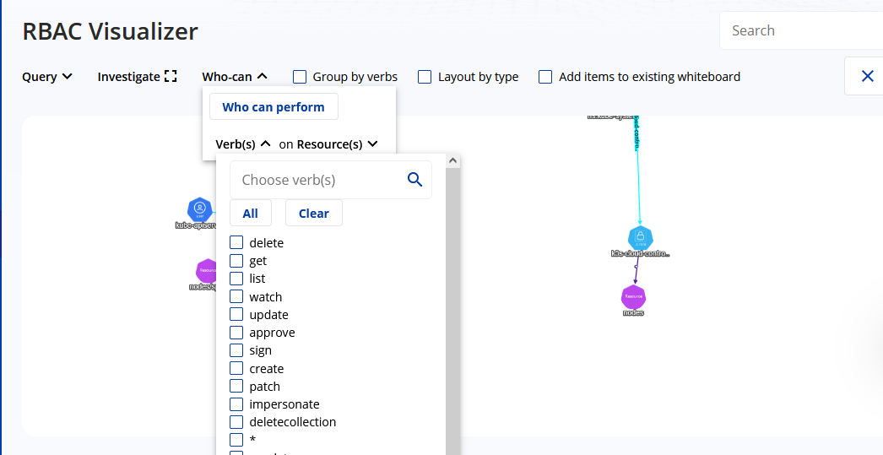

You may also make use of other kinds of framework scanning in accordance with the NSA framework or the MITRE framework. Armo will determine whether or not there are issues depending on the frameworks. You can also scan using the zero trust framework, which will allow you to properly enforce zero trust in your environment.

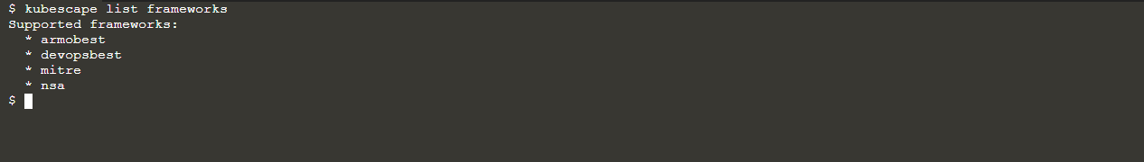

# **Advanced Techniques for Network Segmentation in Kubernetes Clusters**

In Kubernetes clusters, network segmentation is the process of splitting the network into multiple smaller, more autonomous segments to enhance security and the cluster’s overall manageability. Utilizing Kubernetes network policies is an example of a more sophisticated approach to network segmentation. Granular control over network access within a cluster is enabled through network policies, which let administrators establish rules for incoming and outgoing traffic to and from pods. For example, we can implement many different policies, like denying all incoming traffic to specific namespaces or allowing specific pods to communicate with any of the specific pods.

Deny All Incoming Traffic to a Specific Namespace

To deny all incoming traffic to a specific namespace in Kubernetes, a network policy can be created that denies all traffic to pods within that namespace. This policy would be applied at the namespace level and would effectively isolate the pods within that namespace from the rest of the network. Additionally, this policy can be extended to block all egress traffic for that namespace as well.

Allow only specific pods in one namespace to communicate with pods in another namespace:

Only certain pods in one namespace can communicate with pods in another. The policy’s specification can list the pod selectors or labels of pods that can communicate with pods in the other namespace. Only the chosen pods can connect to other namespaces, isolating the others from traffic.

Pod-based network segmentation policies allow or prevent communication between cluster pod groups. This network policy restricts communication between pods labelled

To summarise, network segmentation is an effective strategy that can boost the manageability and security of Kubernetes clusters. Network segmentation can assist in lowering the attack surface of a cluster and limit the effect of a security event by isolating the various types of workloads being performed on the cluster and limiting the flow of network traffic. Additionally, network segmentation can help with compliance and regulatory requirements by offering more granular control over network access. This is one of the benefits of network segmentation.

# **What are Kubernetes Custom Resource Definitions (CRDs)?**

Kubernetes (K8S) has a set of objects ready for use out of the box. But what if you wanted K8S to manage other things, other than Kubernetes itself and the containers it manages? This is where creating your own objects using Custom resource definitions (CRDs) comes in. The use of CRDs makes the possibilities of Kubernetes management almost limitless. You can extend the base Kubernetes API with any object you like using CRDs.

For example, using kubectl to interact with my cluster, I type

kubectl get MyRouter

I get an error:

error: the server doesn't have a resource type "MyRouter"

This is obviously fully expected, MyRouteris not a valid resource name that comes out of the box in the K8S API.

I first need to add the MyRouterobject to my K8S API using a CRD.

Using CRDs can commonly enable K8S to be able to manage other parts of your infrastructure, such as network devices like routers and switches. This might help you avoid having to replace old devices by using K8S modern and streamlined management capabilities.

## Viewing and Creating a CRD

Many tools that you install on your K8S cluster will include the creation of some CRD objects. This is to enable them to provide functionality that is not provided in vanilla K8S. For example, if you have the monitoring tool Prometheus installed on your cluster, it will include the installation of prometheusrules.monitoring.coreos.com CRDs. CRDs are listed in the format <object>.<group> . With these installed I can run the command kubectl get prometheusrules -n prometheus — before the installation of Prometheus on my cluster, these commands would return an error:

error: the server doesn't have a resource type "prometheusrules"

With it installed, the command shows me a list of Prometheus rules.

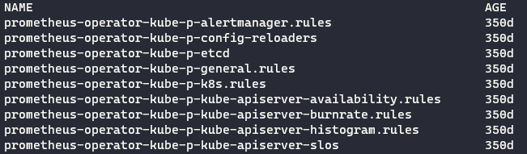

Because CRDs are created with most tool installations, you will likely have some CRDs already installed on your cluster. You can view a list using the command:

kubectl get crd

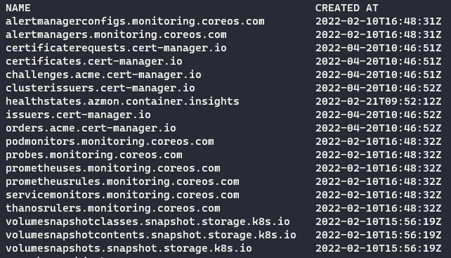

To create a CRD, we need to create a new YAML file. The example below defines a resource definition for switches that I have in my datacenter, that I will manage using K8S. Before you jump in, be aware that most scenarios do not need a new CRD created from scratch, they already have a solution out there on the internet.

I can apply it using:

kubectl apply -f switchcrd.yaml



I can see it added to the list of my CRDs by using the command: kubectl get crd

apiVersion: apiextensions.k8s.io/v1

kind: CustomResourceDefinition

metadata:

name: switches.datacenter.com # name must match the spec fields below, and be in the form: <plural>.<group>

spec:

group: datacenter.com # group name to use for REST API: /apis/<group>/<version>

versions:

- name: v1

served: true # Each version can be enabled/disabled by Served flag.

storage: true # One and only one version must be marked as the storage version.

schema:

openAPIV3Schema:

type: object

properties:

spec:

type: object

properties:

dataCenter:

type: string

rack:

type: integer

type:

type: string

scope: Cluster # either Namespaced or Cluster

names:

plural: switches # plural name to be used in the URL: /apis/<group>/<version>/<plural>

singular: switch # singular name to be used as an alias on the CLI and for display

kind: Switch # kind is normally the CamelCased singular type. Your resource manifests use this.

shortNames: # shortNames allow shorter string to match your resource on the CLI

- sw

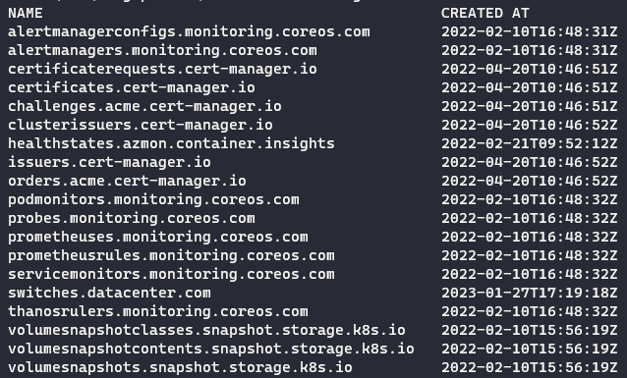

Now I can run the command:

kubectl get switches



This is because we have defined only the definition, not the actual switch device I want to manage.

I’ll create a device called Switch1. Create a new file called *switch1.yaml*:

apiVersion: datacenter.com/v1   
kind: Switch    
metadata:     
 name: switch1   
spec:     
 dataCenter: uksouth     
 rack: 280     
 type: physical

Apply it using the command kubectl apply -f .\switch1.yaml



Now we can list our switches: kubectl get switches

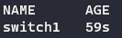

This object is now a part of the K8S API. As it stands it is just a list with some specs, which doesn’t actually do anything other than serve as a data record.

To make use of the custom object we created, we can create a CustomController object to configure our switches, for example. Custom controllers are applications or scripts. They’re deployed on the cluster as pods, and their job is to listen to the Kubernetes API and perform some actions based on defined logic. The CustomController object could be configured to listen to the K8S API for any changes in our switch objects, and make appropriate changes based on those, effectively introducing fully custom automation!

**Summary**

Custom resource definitions (CRDs) enables Kubernetes to be hugely flexible when it comes to deciding what you want it to manage. CRDs are considered a fairly advanced K8S topic. You should understand the basics before diving in!

**Security primitives**

Only ssh key based authentication is enabled for Kubernetes cluster.

Kube-apiserver is the centre of everything, so who can access it (Authentication) and what they can access (Authorization) is important.

**Authentication:**

Files: Username and password  
Files: Username and token  
client certificates  
External authentication providers like LDAP  
Service Accounts

**Authorization:**

RBAC authorization  
ABAC authorization  
Node authorization  
Webhook mode

We can pass the user-details.csv in the kube-apiserver.service configuration as --basic-auth-file parameter. This is not recommended in a production environment. This is only for learning purposes. Also note that this approach is deprecated in Kubernetes version 1.19 and is no longer available in later releases

Follow the below instructions to configure basic authentication in a kubeadm setup.Create a file with user details locally at /tmp/users/user-details.csv

# User File Contents  
password123,user1,u0001  
password123,user2,u0002  
password123,user3,u0003  
password123,user4,u0004  
password123,user5,u0005

Edit the kube-apiserver static pod configured by kubeadm to pass in the user details. The file is located at /etc/kubernetes/manifests/kube-apiserver.yaml

apiVersion: v1

kind: Pod

metadata:

  name: kube-apiserver

  namespace: kube-system

spec:

  containers:

  - command:

    - kube-apiserver

      <content-hidden>

    image: k8s.gcr.io/kube-apiserver-amd64:v1.11.3

    name: kube-apiserver

    volumeMounts:

    - mountPath: /tmp/users

      name: usr-details

      readOnly: true

  volumes:

  - hostPath:

      path: /tmp/users

      type: DirectoryOrCreate

    name: usr-details

Modify the kube-apiserver startup options to include the basic-auth file

apiVersion: v1

kind: Pod

metadata:

creationTimestamp: null

name: kube-apiserver

namespace: kube-system

spec:

containers:

- command:

- kube-apiserver

- --authorization-mode=Node,RBAC

<content-hidden>

- --basic-auth-file=/tmp/users/user-details.csv

Create the necessary roles and role bindings for these users:

---

kind: Role

apiVersion: rbac.authorization.k8s.io/v1

metadata:

namespace: default

name: pod-reader

rules:

- apiGroups: [""] # "" indicates the core API group

resources: ["pods"]

verbs: ["get", "watch", "list"]

---

# This role binding allows "jane" to read pods in the "default" namespace.

kind: RoleBinding

apiVersion: rbac.authorization.k8s.io/v1

metadata:

name: read-pods

namespace: default

subjects:

- kind: User

name: user1 # Name is case sensitive

apiGroup: rbac.authorization.k8s.io

roleRef:

kind: Role #this must be Role or ClusterRole

name: pod-reader # this must match the name of the Role or ClusterRole you wish to bind to

apiGroup: rbac.authorization.k8s.io

Once created, you may authenticate into the kube-api server using the users credentials

curl -v -k https://localhost:6443/api/v1/pods -u "user1:password123"

If the kube api server is configured with client certificates then to connect with Kubernetes we have two options, we can either pass client-key, client-cert and ca-cert everytime in kubectl command or we can also configure then in the **kubeConfig.** We can also pass the kubeConfig path with the kubectl command

# What is a kubeconfig file?

kubeconfig is the default way to authenticate to a Kubernetes cluster. Whether you use [Red Hat OpenShift](https://www.redhat.com/en/technologies/cloud-computing/openshift?intcmp=701f20000012ngPAAQ) or [Kubernetes](https://www.redhat.com/en/topics/containers/what-is-kubernetes?intcmp=701f20000012ngPAAQ) in a bare-metal cluster, the cloud, or a simple virtual machine created with [OpenShift Local](https://developers.redhat.com/products/openshift-local/overview) or [minikube](https://minikube.sigs.k8s.io/docs/start/" \t "_blank), you always have a kubeconfig file. The file contents may differ in some cases, but the principle is the same.

## The kubeconfig file components

Kubernetes components like kubelet, kube-controller-manager, or kubectl use the kubeconfig file to interact with the Kubernetes API. Usually, the kubectl or oc commands use the kubeconfig file.

The kubeconfig file's default location for kubectl or oc is the ~/.kube directory. Instead of using the full kubeconfig name, the file is just named config. The default location of the kubeconfig file is ~/.kube/config. There are other ways to specify the kubeconfig location, such as the KUBECONFIG environment variable or the kubectl --kubeconfig parameter.

The kubeconfig file is a [YAML](https://opensource.com/downloads/yaml-cheat-sheet?intcmp=701f20000012ngPAAQ) file containing groups of **clusters**, **users**, and **contexts**.  
A **cluster** is a Kubernetes or OpenShift cluster.  
A **user** is a credential used to interact with the Kubernetes API.  
A **context** is a combination of a cluster and a user. Every time you execute an oc or kubectl command, you reference a context inside kubeconfig.

View current config file in yaml : **kubectl config view -o yaml**

The following is a sample kubeconfig file from a new minikube installation:

apiVersion: v1

kind: Config

preferences: {}

current-context: minikube

users:

- name: minikube

user:

client-certificate: /Users/abhishekghosh/.minikube/profiles/minikube/client.crt

client-key: /Users/abhishekghosh/.minikube/profiles/minikube/client.key

clusters:

- cluster:

certificate-authority: /Users/abhishekghosh/.minikube/ca.crt

extensions:

- extension:

last-update: Wed, 08 Mar 2023 11:53:26 IST

provider: minikube.sigs.k8s.io

version: v1.29.0

name: cluster\_info

server: https://127.0.0.1:49154

name: minikube

contexts:

- context:

cluster: minikube

extensions:

- extension:

last-update: Wed, 08 Mar 2023 11:53:26 IST

provider: minikube.sigs.k8s.io

version: v1.29.0

name: context\_info

namespace: default

user: minikube

name: minikube

Here are some additional details on clusters, contexts, and users.

The **clusters** section lists all clusters that you already connected. In this case, there is only one, named **minikube**. This name is arbitrary and can be any name you like. Inside the cluster are two keys:

**certificate-authority** contains a certificate for the [certificate authority (CA)](https://www.redhat.com/sysadmin/who-signed-my-cert) that signed all internal Kubernetes certificates. This can be a file path or a [Base64](https://www.redhat.com/sysadmin/base64-encoding) string of the certificate's Privacy Enhanced Mail (PEM) format.  
**server** is the address of the server.

The **users** section lists all users already used to connect to a cluster. In this case, there is only a single user, named **minikube**. This name is arbitrary, and there is no relationship with any object inside Kubernetes or OpenShift. There are some possible keys for a user:  
**client-certificate** contains a certificate for the user signed by the Kubernetes CA. This can be a file path or a Base64 string in the certificate PEM format.  
**client-key** contains the key that signed the client certificate.  
**token** contains a token for this user when there is no certificate.

The **contexts** section specifies a combination of a user and a cluster. It also defines a default namespace for this pair. The context name is arbitrary, but the user and cluster should be predefined inside the kubeconfig file. If the namespace does not exist inside Kubernetes, the commands will fail and display the default Kubernetes message for a nonexistent namespace.

By default, there is no user object inside Kubernetes. Kubernetes uses an X.509 certificate to authenticate the default cluster administrator. The X.509 certificate tells Kubernetes about the user trying to access resources.

To inspect an X.509 certificate, use the openssl command. The example above contains a client-certificate pointing to a file. You can use the following command to check it:

**$** openssl x509 -noout -text -**in** /home/hector/.minikube/profiles/minikube/client.crt

Certificate:

Data:

Version: 3 (0x2)

Serial Number: 2 (0x2)

Signature Algorithm: sha256WithRSAEncryption

Issuer: CN = minikubeCA

Validity

Not Before: Nov 23 18:50:27 2022 GMT

Not After : Nov 23 18:50:27 2025 GMT

Subject: O = system:masters, CN = minikube-user

Subject Public Key Info:

...

X509v3 extensions:

X509v3 Key Usage: critical

Digital Signature, Key Encipherment

X509v3 Extended Key Usage:

TLS Web Server Authentication, TLS Web Client Authentication

X509v3 Basic Constraints: critical

CA:FALSE

...

Look for the **Subject** information and **X.509v3** extensions. The concepts and requirements for these extensions are outside the scope of this article, but they are necessary for this kind of authentication.

The **Subject** is an X.509 directive that specifies information like the **CN** (Common Name), **O** (Organization), **OU** (Organization Number), **C** (Country), and so forth. Take a closer look at the **O** field. The value is **system:masters**. This tells Kubernetes that this certificate belongs to a member of the group **system:masters**. In this case, there is no user, but the group is enough.

Take a look inside Kubernetes and find the role-based access control (RBAC) objects that manage this authentication:

$ kubectl get clusterrolebinding cluster-admin -o yaml

# Output:

apiVersion: rbac.authorization.k8s.io/v1

kind: ClusterRoleBinding

metadata:

labels:

kubernetes.io/bootstrapping: rbac-defaults

name: cluster-admin

roleRef:

apiGroup: rbac.authorization.k8s.io

kind: ClusterRole

name: cluster-admin

subjects:

- apiGroup: rbac.authorization.k8s.io

kind: Group

name: system:masters

This **clusterrolebinding** connects the **cluster-admin** clusterrole to the **system:masters** group.

The same logic is used for other Kubernetes components, as you can see inside /etc/kubernetes:

**$** ls /etc/kubernetes/\*.conf

**#** Output:

/etc/kubernetes/admin.conf  /etc/kubernetes/controller-manager.conf  /etc/kubernetes/kubelet.conf  /etc/kubernetes/scheduler.conf

Each of these files is a kubeconfig file for a specific component with a particular user and certificate.

You can change the context manually by editing the kubeconfig file, but this can lead to errors. If you want to change the default namespace for Kubernetes, you can execute the following command:

**$** kubectl config set-context --current --namespace kube-system

This command is safer. It will modify the kubeconfig file, changing the namespace inside the current context.

You can use other commands. For example, commands exist to completely change a context or even create a new one from scratch.

The kubeconfig file is the default way to authenticate to a Kubernetes cluster. It can be a little cryptic because of the embedded certificates, but it is easy to understand if you look closely. The kubeconfig file can contain clusters, users, and contexts. It is possible to switch between them with kubectl config use-context.

The OpenShift client is user-friendly because it can create a kubeconfig file if none exists after the oc login command. However, you can create a kubeconfig by executing some kubectl config commands.

**See this : https://www.youtube.com/watch?v=\_65Md2qar14**

In order to connect to kube server apis we need to use kubectl proxy, which will launch a proxy service to call the kubeservice apis with client.key and client.cert

**Authorization mechanism:**

Node Authorizations  
Attribute based authorizations  
Role based Authorizations  
Webhook  
AlwaysAllow  
AlwaysDeny

Authorization mechanism is specified by the **--authorization-mode** option in the kube-api server. If we don’t specify anything in that option then it is set to **AlwaysAllow** option. We can add multiple values in comma-separated format in authorization mode option and kube-api will check the user access via iterating orderly in that options. If in any option user is granted the access then kube-api will not check the remaining options.

Role and RoleBinding

**Kubectl get,describe commands**

Check if I have the access or not :  
**kubectl auth can-I create/delete deployments/pods/comfigmaps**

Admin user can also check if the other user has the specific option or not:  
**kubectl auth can-I create/delete deployments/pods/comfigmaps --as dev-user**

We can also restrict users to have access in specific namespace or specific resources like only blue or red pods.

To view the kube-api server configurations:

minikube ssh  
sudo cat etc/kubernetes/manifests/kube-apiserver.yaml

check the authorization modes:

ps -aux | grep authorization

kubectl get roles -A --no-headers | wc -l -> To get role counts

Role and RoleBindings are namespaced but we know that we can not associate any node or cluster to any namespace those were cluster scoped. To check which are name-spaced and which are not we can use the following command.

kubectl api-resources --namespaced=true  
kubectl api-resources --namespaced=false

To add the authorization and authentication on the resources which are cluster scoped we will use ClusterRole and ClusterRoleBinding

We can update or view the admission-controllers of kube-apiserver in **--enable-admission-plugins** option in kube-apiserver.service or kube-apiserver.yaml under manifest folder in minikube Kubernetes. We have also **--disable-admission-plugins** to disable any admission controller.

Mutating and Validating Admission controller.

**API Groups in Kubernetes**

Whatever operations we have done so far with the cluster, we have been interacting with the API server one way or the other. Either through the kubectl utility or directly via REST.

Say we want to check the version; we can access the API server at the master nodes address followed by the port which is 6443 by default and the API version. It returns the version.

Similarly, to get the list of pods, you would access the url api/v1/pods. Our focus in this tutorial is about these API paths. The /version and /api.

The Kubernetes API is grouped into multiple such groups based on their purpose. Such as one for apis, one for healthz, metrics and logs etc.

The version API is for viewing the version of the cluster. The metrics API and healthz API are used to monitor the health of the cluster. The logs for integrating with third party logging applications.

In this tutorial we will focus on the API is responsible for the cluster functionality. These APIs are categorized into two. The core group and the named group.

**Core group**

The core group is where all core functionality exists. Such as namespaces, PODs, replication controllers, events, endpoints, nodes, bindings, Persistent volumes, persistent volume claims, configmaps, secrets, services etc.

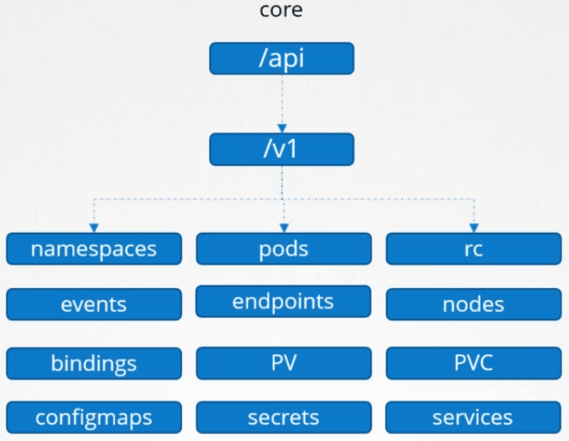

**Named group.**

The named group API are more organized and going forward all the newer features are going to be made available to these named groups. It has groups under it for apps, extensions, networking, storage, authentication, authorization certificates etc. Shown here are just a few.

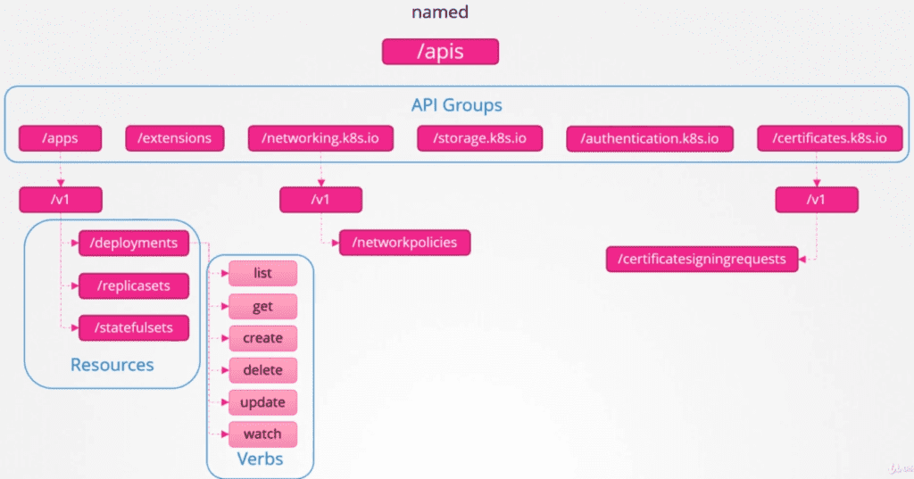

Within apps, you have deployments, ReplicaSets, StatefulSets. Within networking you have network policies certificates have these certificates sign requests. So the ones at the top are API groups and the ones at the bottom are resources in those groups. Each resource in this has a set of actions associated with them.

Things that you can do with these resources such as list the deployments, get information about one of these deployments, create a deployment, delete a deployment, update a deployment watch a deployment etc. These are known as verbs.

**API Reference**

The [Kubernetes API reference page](https://kubernetes.io/docs/reference/generated/kubernetes-api/v1.19/#pod-v1-core) can tell you what the API group is for each object select an object and the first section in the documentation page shows its group details v1/core is just v1.

You can also view these on your Kubernetes cluster. Access your Kube API server at port 6443, without any path and it will list you the available API groups. And then within the named API groups it returns all supported groups.

A quick note on accessing the cluster API like that. If you were to access the API directly through curl as shown here, then you will not be allowed access except for certain APIs like version, as you have not specified any authentication mechanisms.

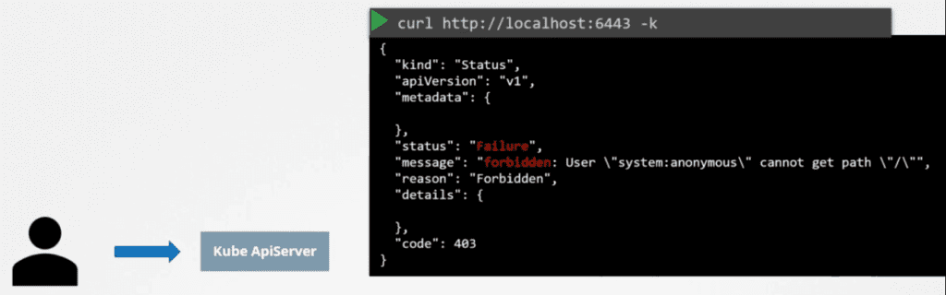

So, you have to authenticate to the API using your certificate files by passing them in the command line like below.

**$ curl http://localhost:6443 -k --key admin.key --cert admin.crt --cacert ca.crt**

**Kubectl proxy**

An alternate option is to start a kubectl proxy client. The ***kubectl proxy*** command, launches a proxy service locally on port 8001 and uses credentials and certificates from your kubeconfig file to access the cluster. That way you don’t have to specify those in the curl command.

Now you can access the kubectl proxy service at port 8001 and the proxy will use the credentials from kube-config file to forward your request to the Kube API Server.

**$ curl http://localhost:8001 -k**

Above command will list all available APIs at root. So, here are 2 terms that kind of sound the same. The Kube proxy and kubectl proxy well they are not the same.

The Kubernetes API is a bit more advanced than just a bunch of HTTP endpoints thrown together. Therefore, it's vital to understand the Kubernetes API structure and be fluent in the terminology before trying to access it from code. Otherwise, the attempt will be quite painful - the official Go client comes with so many bells and whistles that trying to wrap your head around the client and the API concepts simultaneously might overwhelm you quickly.

The Kubernetes API is massive - it has hundreds of endpoints. Luckily, it's pretty consistent, so one needs to understand just a limited number of ideas and then extrapolate this knowledge to the rest of the API. In this post, I'll try to touch upon the concepts I found the most fundamental. I'll favour simplicity and digestibility over academic correctness and completeness of the material. And as usual, I just share my understanding of things and my way of thinking about the topic - so, it's not an API manual but a record of personal learning experience.

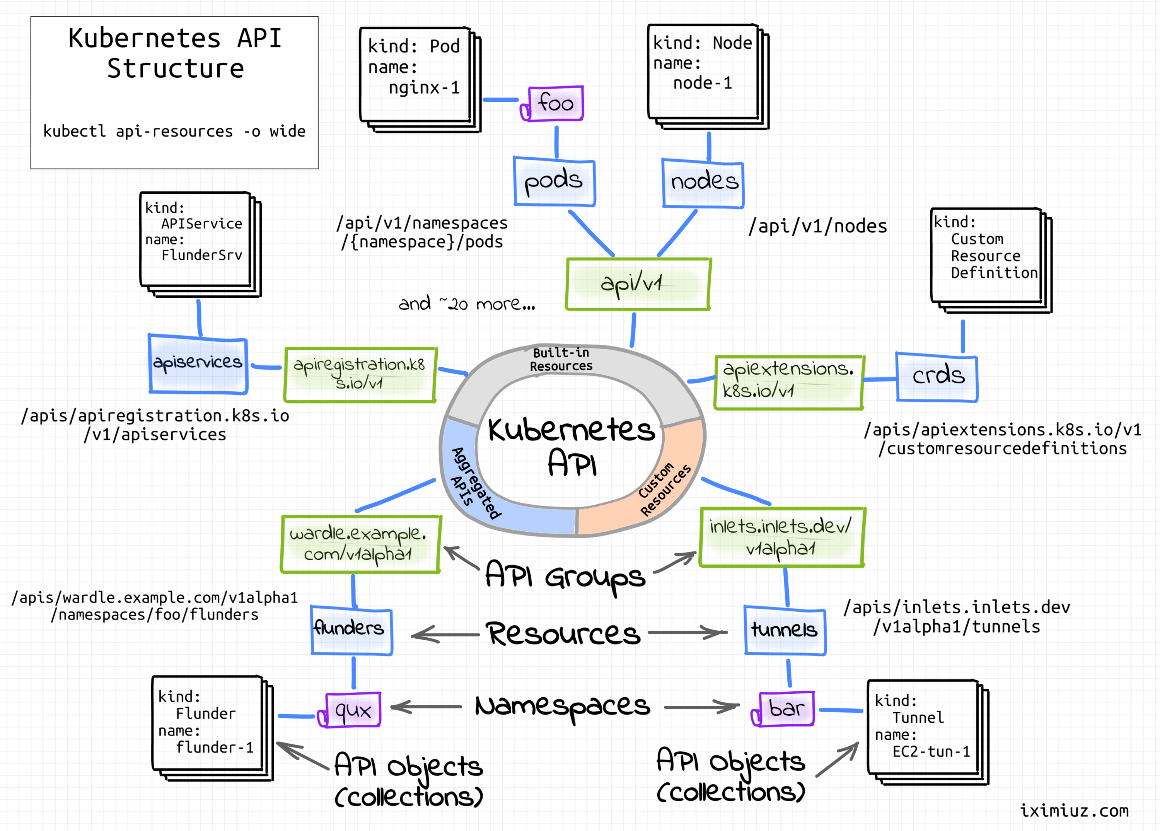

**Resources and Verbs**

Since it's a RESTful land, we'll be operating in terms of *resources* (loosely, objects of a certain structure) and *verbs* (actions on these objects).

When resources are discussed, it's important to differentiate a *resource as a certain kind of objects* from a *resource as a particular instance of some kind*. Thus, Kubernetes API endpoints are officially named [***resource types***](https://kubernetes.io/docs/reference/using-api/api-concepts/#standard-api-terminology) to avoid ambiguity with the *resource instances*. However, in the wild, endpoints are often called just *resources*, and the actual meaning of the word is derived from the context.

[For extensibility reasons](https://kubernetes.io/docs/concepts/overview/kubernetes-api/#api-groups-and-versioning), *resource types* are organized into [***API groups***](https://kubernetes.io/docs/reference/using-api/#api-groups), and the groups are *versioned* independently from each other:

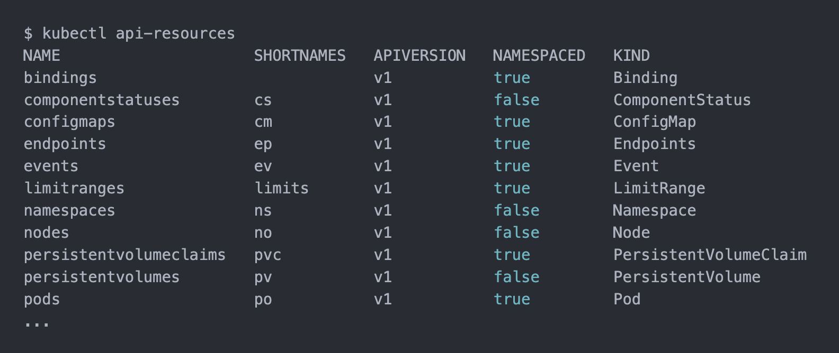

If you're curious how kubectl api-resources command builds such a list of supported resources, here is a nice trick showing what API calls were made by any kubectl command:

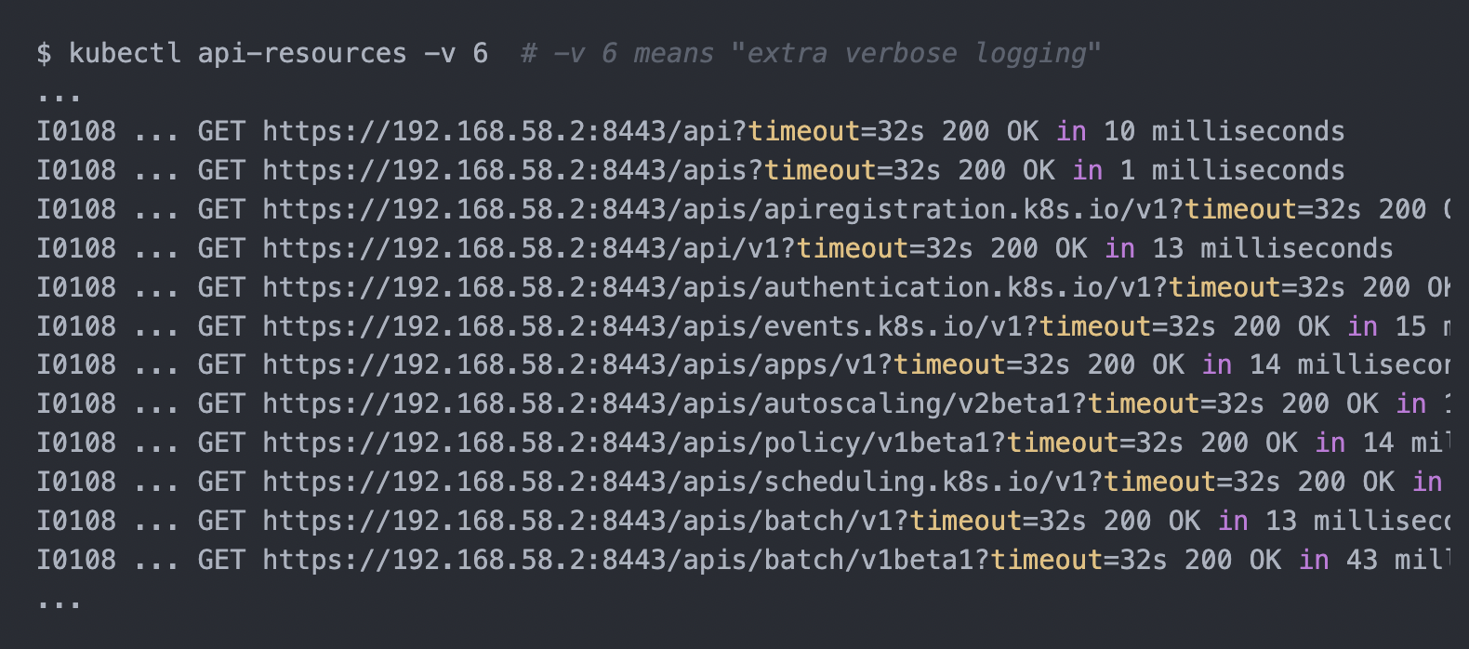

Seems like the Kubernetes API is extremely meta. Apparently, you can list existing (and even [register new resource types](https://iximiuz.com/en/posts/kubernetes-operator-pattern/#kubernetes-custom-resources)) by reading (or creating) other resources! For instance, the above list was obtained by calling the special /api and /apis/<group-name> resources.

The /api endpoint is already legacy and used only for *core* resources (pods, secrets, configmaps, etc.). A more modern and generic /apis/<group-name> endpoint is used for the rest of resources, including user-defined *custom resources*.

You can easily call the above resources (meaning *API endpoints*) using a standard HTTP client like curl and examine the returned resources (meaning *JSON objects*, pun intended):

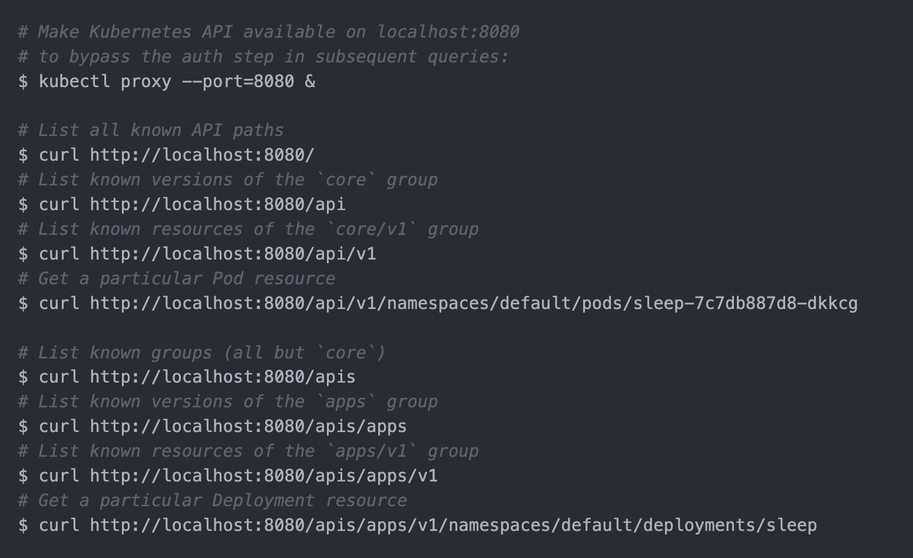

Speaking of the *verbs*, i.e., actions on resources, all the standard CRUD operations with their traditional mapping onto HTTP methods are there. Additionally, *patching* (selective field modification) and *watching* (stream-like collections' reading) of resources are supported. From [sig-architecture/api-conventions.md](https://github.com/kubernetes/community/blob/7f3f3205448a8acfdff4f1ddad81364709ae9b71/contributors/devel/sig-architecture/api-conventions.md#verbs-on-resources):

API resources should use the traditional REST pattern:

GET /<resourceNamePlural> - Retrieve a list of type <resourceName>, e.g. GET /pods returns a list of Pods.

POST /<resourceNamePlural> - Create a new resource from the JSON object provided by the client.

GET /<resourceNamePlural>/<name> - Retrieves a single resource with the given name, e.g. GET /pods/first returns a Pod named 'first'. Should be constant time, and the resource should be bounded in size.

DELETE /<resourceNamePlural>/<name> - Delete the single resource with the given name. DeleteOptions may specify gracePeriodSeconds, the optional duration in seconds before the object should be deleted. Individual kinds may declare fields which provide a default grace period, and different kinds may have differing kind-wide default grace periods. A user provided grace period overrides a default grace period, including the zero grace period ("now").

DELETE /<resourceNamePlural> - Deletes a list of type <resourceName>, e.g. DELETE /pods a list of Pods.

PUT /<resourceNamePlural>/<name> - Update or create the resource with the given name with the JSON object provided by the client.

PATCH /<resourceNamePlural>/<name> - Selectively modify the specified fields of the resource. See more information below.

GET /<resourceNamePlural>?watch=true - Receive a stream of JSON objects corresponding to changes made to any resource of the given kind over time.

Much like resource, the word object in Kubernetes parlance is overloaded. In a broad sense, an object can mean any data structure - an instance of a resource type such as APIGroup, a piece of configuration such as an audit policy, or a persistent entity such as a Pod. However, in this section, I'm going to talk about objects in a narrow, well-defined sense. So, I'll use the capitalized word Object instead.

Entities like ReplicaSet, Namespace, or ConfigMap are called [Kubernetes Objects](https://kubernetes.io/docs/concepts/overview/working-with-objects/kubernetes-objects/). **Objects** are persistent entities in the Kubernetes system that represent an intent (desired state) and the status (actual state) of the cluster.

For instance, once you create a *Pod Object*, Kubernetes will constantly work to ensure that the corresponding collection of containers is running.

Most of the Kubernetes API resources represent Objects. Unlike other forms of resources mandating only the kind field, [Objects must have more field defined](https://github.com/kubernetes/community/blob/7f3f3205448a8acfdff4f1ddad81364709ae9b71/contributors/devel/sig-architecture/api-conventions.md#resources):

* kind - a string that identifies the schema this object should have
* apiVersion - a string that identifies the version of the schema the object should have
* metadata.namespace - a string with the namespace (defaults to "default")
* metadata.name - a string that uniquely identifies this object within the current namespace
* metadata.uid - a unique in time and space value used to distinguish between objects with the same name that have been deleted and recreated.

Additionally, the metadata dictionary may include labels and annotations fields, as well as some versioning and timestamp information.

💡 **Fun fact -** The kubectl api-resources command actually lists not API resources but known types of Kubernetes Objects. To list the true API resources instead, you'd need to run through a full discovery cycle querying every path returned by kubectl get --raw / recursively.

Example - Pod Object (truncated output):

$ kubectl get --raw /api/v1/namespaces/default/pods/sleep-7c7db887d8-dkkcg | python -m json.tool

{

"apiVersion": "v1",

"kind": "Pod",

"metadata": {

"namespace": "default",

"name": "sleep-7c7db887d8-dkkcg",

"uid": "32bf410a-0009-484e-adac-21179ec28f0f",

"labels": {

"app": "sleep",

"pod-template-hash": "7c7db887d8"

},

"creationTimestamp": "2022-01-08T18:10:04Z",

"resourceVersion": "465766"

},

"spec": { ... },

"status": { ... }

}

**Fun fact -** Kubernetes is known as a Production-Grade Container Orchestration system. However, [Container](https://github.com/kubernetes/api/blob/0bfaff8d3672f17c7348fa1c607c4fd346cfc1ba/core/v1/types.go#L2293) is not a Kubernetes Object - it's just an object of a simple kind. But [Pod](https://github.com/kubernetes/api/blob/0bfaff8d3672f17c7348fa1c607c4fd346cfc1ba/core/v1/types.go#L3876), of course, is a full-fledged persistent Object.

As in the above example, it's typical for Kubernetes Objects to have the spec (desired state) and status (actual state) fields. But it's not always the case. Compare the above output with the ConfigMap Object below:

$ kubectl get --raw /api/v1/namespaces/default/configmaps/informer-dynamic-simple-wzgmx | python -m json.tool

{

"apiVersion": "v1",

"kind": "ConfigMap",

"data": {

"foo": "bar"

},

"metadata": {

"namespace": "default",

"name": "informer-dynamic-simple-wzgmx",

"uid": "74471398-0244-4686-b490-7007f6246a63",

"creationTimestamp": "2022-01-06T21:45:04Z",

"generateName": "informer-dynamic-simple-",

"resourceVersion": "418185"

}

}

Dealing with the Kubernetes API from code involves a lot of Object manipulation, so having a solid understanding of a common Object structure is a must. The kubectl explain command can help you with that. The coolest part about it is that it can be called not only on resources but also on the nested fields:

$ kubectl explain deployment.spec.template

KIND: Deployment

VERSION: apps/v1

RESOURCE: template <Object>

DESCRIPTION:

Template describes the pods that will be created.

PodTemplateSpec describes the data a pod should have when created from a

template

FIELDS:

metadata <Object>

Standard object's metadata. More info:

https://git.k8s.io/community/contributors/devel/sig-architecture/api-conventions.md#metadata

spec <Object>

Specification of the desired behavior of the pod. More info:

https://git.k8s.io/community/contributors/devel/sig-architecture/api-conventions.md#spec-and-status

**Summarizing**Resources in Kubernetes parlance can mean both - *resource types* and *resource instances*. Resource types are organized into *API groups*, and API groups are *versioned*. Every resource representation follows a certain schema defined by its *kind*. While every resource follows a concrete structure defined by its kind, not every resource represents a *Kubernetes Object*. Objects are persistent entities representing a record of intent. Objects of different kinds have different structures, but all Objects carry common metadata attributes like namespace, name, uid, or creationTimestamp.

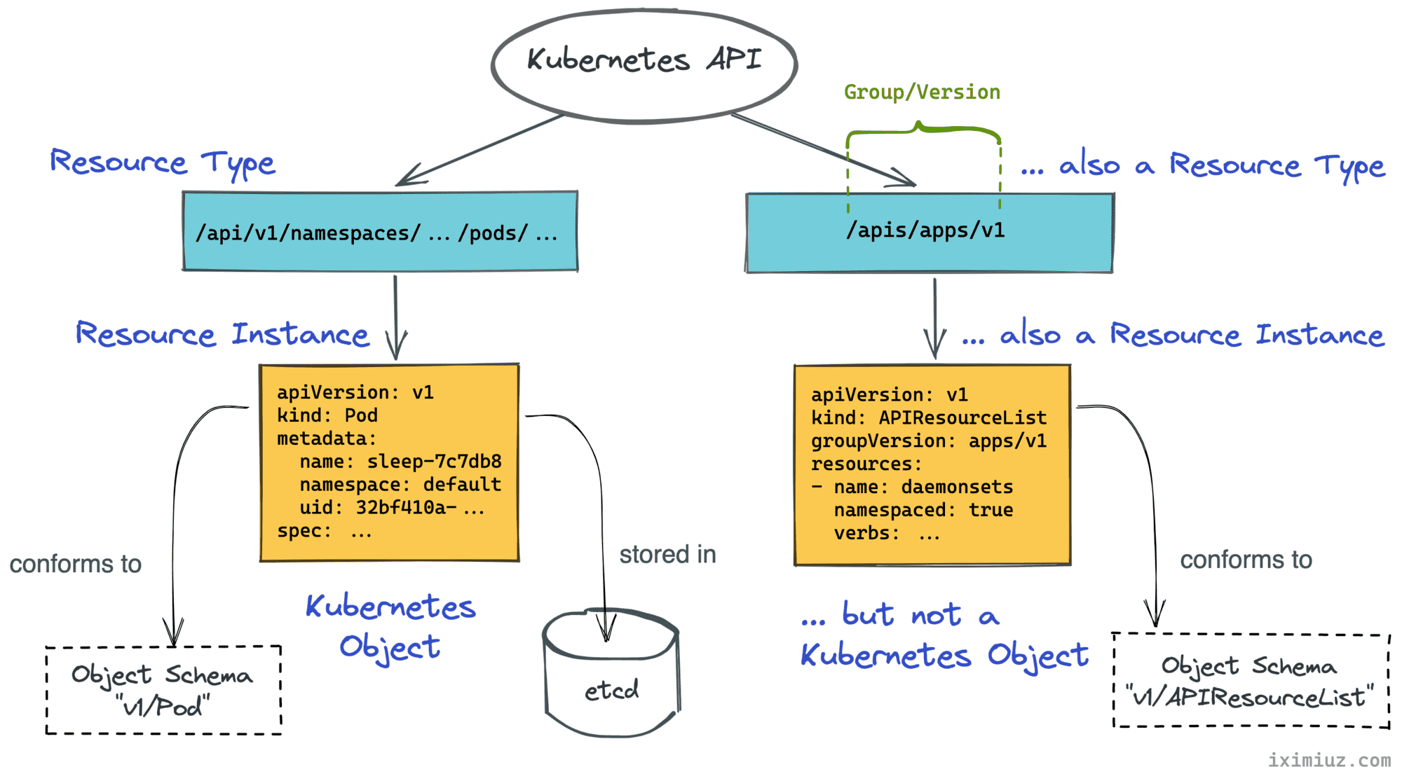

The cluster-info command shows the API address of the cluster that is selected in the [*current context*](https://kubernetes.io/docs/tasks/access-application-cluster/configure-access-multiple-clusters/). But what if you have more than one cluster?

Another way to look up the Kubernetes API server address is through looking at the *[kubeconfig](https://kubernetes.io/docs/concepts/configuration/organize-cluster-access-kubeconfig/)* content:

$ kubectl config view

apiVersion: v1

clusters:

- name: cluster1

cluster:

...

server: https://192.168.58.2:8443

- name: cluster2

cluster:

...

server: https://192.168.59.2:8443

...

So, pick the right cluster from the above list, and let's try to send a request to its API server:

$ KUBE\_API=$(kubectl config view -o jsonpath='{.clusters[0].cluster.server}')

### Authenticating API server to client

Let's start from querying the API's /version endpoint:

$ curl $KUBE\_API/version

curl: (60) SSL certificate problem: unable to get local issuer certificate

More details here: https://curl.haxx.se/docs/sslcerts.html

the above error actually makes sense. By default, Kubernetes exposes its API via HTTPS, in particular, to guarantee a strong identity of the API server to the clients. However, *minikube* bootstrapped my local cluster using a self-signed certificate. Thus, the TLS cert of the Kubernetes API server turned out to be signed by a Certificate Authority (CA) *minikubeCA* that is unknown to *curl*. Since *curl* cannot trust it, the request fails.

Luckily, minikube thoughtfully saves the CA cert to ~/.minikube/ca.crt

So, to fix the GET /version request, I just need to make curl trust the issuer of the API server certificate by pointing it to the minikubeCA cert manually:

$ curl --cacert ~/.minikube/ca.crt $KUBE\_API/version

{

"major": "1",

"minor": "22",

"gitVersion": "v1.22.3",

"gitCommit": "c92036820499fedefec0f847e2054d824aea6cd1",

"gitTreeState": "clean",

"buildDate": "2021-10-27T18:35:25Z",

"goVersion": "go1.16.9",

"compiler": "gc",

"platform": "linux/amd64"

}

### Authenticating Client to API Server using Certificates

Ok, let's try something more complicated. How about listing all Deployments in the cluster?

$ curl --cacert ~/.minikube/ca.crt $KUBE\_API/apis/apps/v1/deployments

{

"kind": "Status",

"apiVersion": "v1",

"metadata": {

},

"status": "Failure",

"message": "deployments.apps is forbidden: User \"system:anonymous\" cannot list resource \"deployments\" in API group \"apps\" at the cluster scope",

"reason": "Forbidden",

"details": {

"group": "apps",

"kind": "deployments"

},

"code": 403

}

And... it didn't work again.

Unlike the apparently unprotected /version endpoint, Kubernetes generally restricts access to its API endpoints.

As it's clear from the error message, the request was authenticated as a User "system:anonymous", and evidently, this user is unauthorized to list Deployment resources.

The failed request didn't include any authentication means (nevertheless, it was authenticated, but as an anonymous user), so I need to provide some extra piece of information to get the desired level of access.

Kubernetes supports [several authentication mechanisms](https://kubernetes.io/docs/reference/access-authn-authz/authentication/), and I'll start from authenticating requests using a client certificate.

But wait a minute! What is a client certificate?

When minikube bootstrapped the cluster, it also created a user. This user got a certificate signed by the same minikubeCA authority. Since this CA is trusted by the Kubernetes API server, presenting this certificate in the request will make it authenticated as the said user.

Kubernetes does not have objects which represent *users*. I.e., users cannot be added to a cluster through an API call. However, any user that presents a valid certificate signed by the cluster's Certificate Authority is considered authenticated. Kubernetes takes the username from the common name field in the cert's *subject* (e.g., CN = minikube-user). Then, the Kubernetes RBAC sub-system determines whether the user is authorized to perform a specific operation on a resource.

User certificates typically can be found in the already familiar to us kubectl config view output:

$ kubectl config view -o jsonpath='{.users[0]}' | python -m json.tool

{

"name": "cluster1",

"user": {

"client-certificate": "/home/vagrant/.minikube/profiles/cluster1/client.crt",

"client-key": "/home/vagrant/.minikube/profiles/cluster1/client.key"

}

}

Let's check the certificate content real quick to make sure it's signed by the same CA:

$ cat ~/.minikube/profiles/cluster1/client.crt | openssl x509 -text

Certificate:

Data:

Version: 3 (0x2)

Serial Number: 2 (0x2)

Signature Algorithm: sha256WithRSAEncryption

Issuer: CN = minikubeCA

Validity

Not Before: Dec 26 06:35:56 2021 GMT

Not After : Dec 26 06:35:56 2024 GMT

Subject: O = system:masters, CN = minikube-user

And here is how to send a request authenticated by that certificate to the Kubernetes API server using *curl*:

$ curl $KUBE\_API/apis/apps/v1/deployments \

--cacert ~/.minikube/ca.crt \

--cert ~/.minikube/profiles/cluster1/client.crt \

--key ~/.minikube/profiles/cluster1/client.key

{

"kind": "DeploymentList",

"apiVersion": "apps/v1",

"metadata": {

"resourceVersion": "654514"

},

"items": [...]

}

**Authenticating Client to API Server using Service Account Tokens**

Another way to authenticate API requests is through using a bearer header containing a valid [Service Account](https://kubernetes.io/docs/tasks/configure-pod-container/configure-service-account/) JWT token.

Since Kubernetes 1.24, Secret API objects containing Service Account tokens are no longer auto-generated for every ServiceAccount object. The recommended way to obtain a Service Account token now is through using the dedicated [TokenRequest API](https://kubernetes.io/docs/reference/kubernetes-api/authentication-resources/token-request-v1/) or the corresponding kubectl create token command. [Read this for more](https://kubernetes.io/docs/concepts/configuration/secret/#service-account-token-secrets).

Much like with users, different Service Accounts will have different levels of access. Let's see what can be achieved with the *default* Service Account from the *default* namespace:

Create a secret and get the token from it.

apiVersion: v1

kind: Secret

metadata:

name: default

annotations:

kubernetes.io/service-account.name: default

type: kubernetes.io/service-account-token

then get the jwt token from the secret that is mounted with the default service account

**JWT\_TOKEN=$(kubectl get secret default -o jsonpath='{.data.token}' | base64 --decode)**

Starting from a simple task - listing known API resource types in the apps/v1 group:

$ curl $KUBE\_API/apis/apps/v1/ \

--cacert ~/.minikube/ca.crt \

--header "Authorization: Bearer $JWT\_TOKEN "

{

"kind": "APIResourceList",

"apiVersion": "v1",

"groupVersion": "apps/v1",

"resources": [...]

}

Raising the bar - let's try to list the actual Deployment objects in the *default* namespace:

$ curl $KUBE\_API/apis/apps/v1/namespaces/default/deployments \

--cacert ~/.minikube/ca.crt \

--header "Authorization: Bearer $JWT\_TOKEN\_DEFAULT\_DEFAULT"

{

"kind": "Status",

"apiVersion": "v1",

"metadata": {

},

"status": "Failure",

"message": "deployments.apps is forbidden: User \"system:serviceaccount:default:default\" cannot list resource \"deployments\" in API group \"apps\" in the namespace \"default\"",

"reason": "Forbidden",

"details": {

"group": "apps",

"kind": "deployments"

},

"code": 403

}

And apparently, the user system:serviceaccount:default:default is not powerful enough to even list Kubernetes Objects in its own namespace.

**JWT\_TOKEN\_KUBE\_SYSTEM=$(kubectl get secret default -n kube-system -o jsonpath='{.data.token}' | base64 --decode)**

The mighty account deserves a challenging task - listing cluster-level resources:

$ curl $KUBE\_API/apis/apps/v1/deployments \

--cacert ~/.minikube/ca.crt \

--header "Authorization: Bearer $JWT\_TOKEN\_KUBESYSTEM\_DEFAULT"

{

"kind": "DeploymentList",

"apiVersion": "apps/v1",

"metadata": {

"resourceVersion": "656580"

},

"items": [...]

}

Yep, works as expected

### How to call Kubernetes API from inside a Pod

Much like any other Kubernetes service, the Kubernetes API service address is available to Pods through environment variables:

$ kubectl run -it --image curlimages/curl --restart=Never mypod -- sh

$ env | grep KUBERNETES

KUBERNETES\_SERVICE\_PORT=443

KUBERNETES\_PORT=tcp://10.96.0.1:443

KUBERNETES\_PORT\_443\_TCP\_ADDR=10.96.0.1

KUBERNETES\_PORT\_443\_TCP\_PORT=443

KUBERNETES\_PORT\_443\_TCP\_PROTO=tcp

KUBERNETES\_SERVICE\_PORT\_HTTPS=443

KUBERNETES\_PORT\_443\_TCP=tcp://10.96.0.1:443

KUBERNETES\_SERVICE\_HOST=10.96.0.1

Pods also typically have the Kubernetes CA cert and Service Account secret materials mounted at /var/run/secrets/kubernetes.io/serviceaccount/. So, applying the knowledge from the above sections, the curl command to call the Kubernetes API server from a Pod can look as follows:

$ curl https://${KUBERNETES\_SERVICE\_HOST}:${KUBERNETES\_SERVICE\_PORT}/apis/apps/v1 \

--cacert /var/run/secrets/kubernetes.io/serviceaccount/ca.crt \

--header "Authorization: Bearer $(cat /var/run/secrets/kubernetes.io/serviceaccount/token)"

### Creating, Reading, Watching, Updating, Patching, and Deleting objects

The Kubernetes API [supports the following operations on Kubernetes Objects](https://github.com/kubernetes/community/blob/7f3f3205448a8acfdff4f1ddad81364709ae9b71/contributors/devel/sig-architecture/api-conventions.md#verbs-on-resources):

GET /<resourcePlural> - Retrieve a list of type <resourceName>.

POST /<resourcePlural> - Create a new resource from the JSON

object provided by the client.

GET /<resourcePlural>/<name> - Retrieves a single resource with the

given name.

DELETE /<resourcePlural>/<name> - Delete the single resource with the

given name.

DELETE /<resourcePlural> - Deletes a list of type <resourceName>.

PUT /<resourcePlural>/<name> - Update or create the resource with the given

name with the JSON object provided by client.

PATCH /<resourcePlural>/<name> - Selectively modify the specified fields of

the resource.

GET /<resourcePlural>?watch=true - Receive a stream of JSON objects

corresponding to changes made to any

resource of the given kind over time.

The API is RESTful, so the above mapping of HTTP methods on the resource actions should look familiar.

Even though the doc mentions only *JSON objects*, submitting YAML payloads is supported if the Content-Type header is set to application/yaml.

Here is how to **create a new object** using *curl* and a YAML manifest:

$ curl $KUBE\_API/apis/apps/v1/namespaces/default/deployments \

--cacert ~/.minikube/ca.crt \

--cert ~/.minikube/profiles/cluster1/client.crt \

--key ~/.minikube/profiles/cluster1/client.key \

-X POST \

-H 'Content-Type: application/yaml' \

-d '---

apiVersion: apps/v1

kind: Deployment

metadata:

name: sleep

spec:

replicas: 1

selector:

matchLabels:

app: sleep

template:

metadata:

labels:

app: sleep

spec:

containers:

- name: sleep

image: curlimages/curl

command: ["/bin/sleep", "365d"]

'

Here is how to **get all objects in the *default* namespace**:

$ curl $KUBE\_API/apis/apps/v1/namespaces/default/deployments \

--cacert ~/.minikube/ca.crt \

--cert ~/.minikube/profiles/cluster1/client.crt \

--key ~/.minikube/profiles/cluster1/client.key

And how to **get an object by a *name* and a *namespace***:

$ curl $KUBE\_API/apis/apps/v1/namespaces/default/deployments/sleep \

--cacert ~/.minikube/ca.crt \

--cert ~/.minikube/profiles/cluster1/client.crt \

--key ~/.minikube/profiles/cluster1/client.key

A more advanced way of retrieving Kubernetes resources is continuously **watching** them for changes:

$ curl $KUBE\_API/apis/apps/v1/namespaces/default/deployments?watch=true \

--cacert ~/.minikube/ca.crt \

--cert ~/.minikube/profiles/cluster1/client.crt \

--key ~/.minikube/profiles/cluster1/client.key

Notice that only a collection of resources can be watched. However, you can narrow down the result set to a single resource by providing a label- or field selector.

Here is how to **update an existing object**:

$ curl $KUBE\_API/apis/apps/v1/namespaces/default/deployments/sleep \

--cacert ~/.minikube/ca.crt \

--cert ~/.minikube/profiles/cluster1/client.crt \

--key ~/.minikube/profiles/cluster1/client.key \

-X PUT \

-H 'Content-Type: application/yaml' \

-d '---

apiVersion: apps/v1

kind: Deployment

metadata:

name: sleep

spec:

replicas: 1

selector:

matchLabels:

app: sleep

template:

metadata:

labels:

app: sleep

spec:

containers:

- name: sleep

image: curlimages/curl

command: ["/bin/sleep", "730d"] # <-- Making it sleep twice longer

'

Here is how to **patch an existing object**:

$ curl $KUBE\_API/apis/apps/v1/namespaces/default/deployments/sleep \

--cacert ~/.minikube/ca.crt \

--cert ~/.minikube/profiles/cluster1/client.crt \

--key ~/.minikube/profiles/cluster1/client.key \

-X PATCH \

-H 'Content-Type: application/merge-patch+json' \

-d '{

"spec": {

"template": {

"spec": {

"containers": [

{

"name": "sleep",

"image": "curlimages/curl",

"command": ["/bin/sleep", "1d"]

}

]

}

}

}

}'

Beware that UPDATE and PATCH are quite tricky operations. The first one is subject to various version conflicts, and the behavior of the second one [differs depending on the used patch strategy](https://kubernetes.io/docs/tasks/manage-kubernetes-objects/update-api-object-kubectl-patch/).

Last but not least - here is how to **delete a collection of objects**:

$ curl $KUBE\_API/apis/apps/v1/namespaces/default/deployments \

--cacert ~/.minikube/ca.crt \

--cert ~/.minikube/profiles/cluster1/client.crt \

--key ~/.minikube/profiles/cluster1/client.key \

-X DELETE

And here is how to **delete a single object**:

$ curl $KUBE\_API/apis/apps/v1/namespaces/default/deployments/sleep \

--cacert ~/.minikube/ca.crt \

--cert ~/.minikube/profiles/cluster1/client.crt \

--key ~/.minikube/profiles/cluster1/client.key \

-X DELETE

## How to call Kubernetes API using kubectl

The above trickery with certificates and tokens was fun. Going through it at least once is a nice exercise to solidify the understanding of the client's and server's moving parts. However, doing it on a daily basis when you have a working kubectl at your disposal would probably be overkill.

### Calling Kubernetes API using kubectl proxy

With a properly configured kubectl tool, you can greatly simplify the API access by using the kubectl proxy command.

If you already have working kubectl, why would you want to call the Kubernetes API directly? 🤔

Well, the reasons are aplenty. For instance, you might be developing a controller and want to play around with the API queries without writing extra code. Or, you may be unhappy with what kubectl does under the hood while manipulating resources, which makes you want to have more fine-grained control over the operations on Kubernetes Objects.

The kubectl proxy command creates a proxy server (or an application-level gateway) between your localhost and the Kubernetes API server. But there must be more to it than just that. Otherwise, why would it be so handy?

The proxy kubectl offloads the mutual client-server authentication responsibility from the caller. Since the communication between the caller and the proxy happens over the localhost, it's considered secure. And the proxy itself takes care of the client-server authentication using the information from the current context selected in the kubeconfig file.

$ kubectl config current-context

cluster1

$ kubectl proxy --port=8080 &

After starting the proxy server, calling the Kubernetes API server becomes much simpler:

$ curl localhost:8080/apis/apps/v1/deployments

{

"kind": "DeploymentList",

"apiVersion": "apps/v1",

"metadata": {

"resourceVersion": "660883"

},

"items": [...]

}

### Calling Kubernetes API using kubectl raw mode

Another cool trick I learned recently is the raw mode some kubectl commands support:

*# Sends HTTP GET request*

$ kubectl get --raw /api/v1/namespaces/default/pods

*# Sends HTTP POST request*

$ kubectl create --raw /api/v1/namespaces/default/pods -f file.yaml

*# Sends HTTP PUT request*

$ kubectl replace --raw /api/v1/namespaces/default/pods/mypod -f file.json

*# Sends HTTP DELETE request*

$ kubectl delete --raw /api/v1/namespaces/default/pods

kubectl is a pretty advanced tool, and even simple commands like kubectl get have a non-trivial amount of code behind it. However, when the --raw flag is used, the [implementation boils down to converting the only argument into an API endpoint URL and invoking the raw REST API client](https://github.com/kubernetes/kubectl/blob/c4379b82ccb7cd7cb496a38ba1e0dc1ec4700be6/pkg/cmd/get/get.go#L463-L469).

Some of the advantages of this method are:

* The raw REST API client uses the same authentication means a baked command would use (anything that's configured in the kubeconfig file)
* These commands support the traditional file-based manifest input via -f flag.

But there is also a disadvantage - I couldn't find any any PATCH or WATCH support, so curl access gives you more power.

## Kubernetes API calls equivalent to a kubectl command

I mentioned a couple of times already that you might be unsatisfied with the actual sequence of requests a particular kubectl command emits. But how can you even know this sequence without reading the code?

Here is a nice trick - you can add the -v 6 flag to any kubectl command, and the logs will become so verbose that you'll start seeing the issued HTTP requests to the Kubernetes API server.

For instance, that's how you can learn that the kubectl scale deployment command is implemented with a PATCH request to the /deployments/<name>/scale subresource:

$ kubectl scale deployment sleep --replicas=2 -v 6

I0116 ... loader.go:372] Config loaded from file: /home/vagrant/.kube/config

I0116 ... cert\_rotation.go:137] Starting client certificate rotation controller

I0116 ... round\_trippers.go:454] GET https://192.168.58.2:8443/apis/apps/v1/namespaces/default/deployments/sleep 200 OK in 14 milliseconds

I0116 ... round\_trippers.go:454] PATCH https://192.168.58.2:8443/apis/apps/v1/namespaces/default/deployments/sleep/scale 200 OK in 12 milliseconds

deployment.apps/sleep scaled

Check out kubectl apply -v 6, the result might be insightful.

Wanna see the actual request and response bodies? Increase the log verbosity up to **8**.

The need to access the Kubernetes API for the first time might be terrifying - there is a lot of new concepts like [Resources, API Groups, Kinds, Objects](https://iximiuz.com/en/posts/kubernetes-api-structure-and-terminology/), clusters, contexts, certificates, oh my! But once you decompose it on the building blocks and gain some hands-on experience through performing trivial tasks like figuring out the API server address or calling a bunch of endpoints with curl, you'll quickly realize that this zoo of ideas isn't really something new - it's just a combination of well-known mechanisms that served us well for many years - REST architectural style, TLS certificates, JWT tokens, object schemes, etc.

So, fear not and run some queries!

**P.S.** Can't wait any longer to try calling the API from code? Check out [collection of Kubernetes client-go examples](https://github.com/iximiuz/client-go-examples) on GitHub

# **Call Kubernetes API using Go**

The official Kubernetes Go client comes loaded with high-level abstractions - *Clientset*, *Informers*, *Cache*, *Scheme*, *Discovery*, oh my! When I tried to use it without learning the moving parts first, I ran into an overwhelming amount of new concepts. It was an unpleasant experience, but more importantly, it worsened my ability to make informed decisions in the code.

So, I decided to **unravel** **client-go** for myself by taking a thorough look at its components.

But where to start? Before dissecting [client-go](https://github.com/kubernetes/client-go) itself, it's probably a good idea to understand its two main dependencies - [k8s.io/api](https://github.com/kubernetes/api) and [k8s.io/apimachinery](https://github.com/kubernetes/apimachinery) modules. It'll simplify the main task, but that's not the only benefit. These two modules were factored out for a reason - they can be used not only by clients but also on the server-side or by any other piece of software dealing with Kubernetes objects.

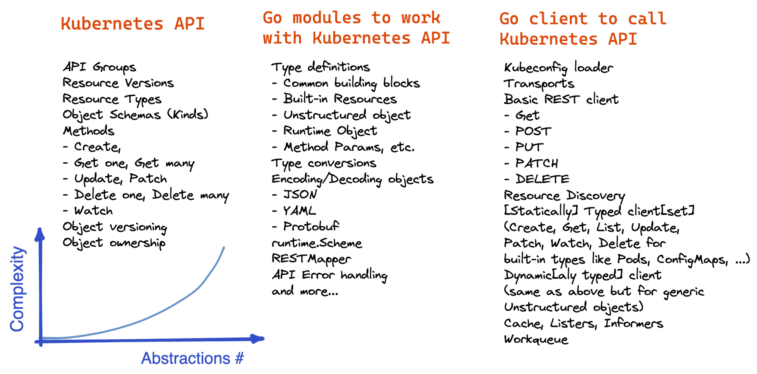

It's also important to differentiate between *objects* in a broad sense and Kubernetes "first-class" *Objects* - persistent entities like *Pod*, *Service*, or *Secret* serving as a record of intent for the cluster. While every API object must have an *API version* and *kind* attributes for the sake of its serialization and deserialization, not every API object is a "first-class" Kubernetes Object.



**Module k8s.io/api**

Go is a statically typed programming language. So, where do all the *structs* corresponding to *Pods*, *ConfigMaps*, *Secrets*, and other first-class Kubernetes Objects live? Right, in [k8s.io/api](https://github.com/kubernetes/api).

Despite the loose naming, the k8s.io/api module seems to be solely for API type definitions. It's full of concrete structs closely resembling those YAML manifests.

package main

import (

"fmt"

appsv1 "k8s.io/api/apps/v1"

corev1 "k8s.io/api/core/v1"

)

func main() {

deployment := appsv1.Deployment{

Spec: appsv1.DeploymentSpec{

Template: corev1.PodTemplateSpec{

Spec: corev1.PodSpec{

Containers: []corev1.Container{

{ Name: "web", Image: "nginx:1.21" },

},

},

},

},

}

fmt.Printf("%#v", &deployment)

}

The module defines not only the top-level Kubernetes Objects like the Deployment above but also numerous auxiliary types for their inner attributes:

*// PodSpec is a description of a pod.*

type PodSpec struct {

Volumes []Volume `json:"volumes,omitempty" patchStrategy:"merge,retainKeys" patchMergeKey:"name" protobuf:"bytes,1,rep,name=volumes"`

InitContainers []Container `json:"initContainers,omitempty" patchStrategy:"merge" patchMergeKey:"name" protobuf:"bytes,20,rep,name=initContainers"`

Containers []Container `json:"containers" patchStrategy:"merge" patchMergeKey:"name" protobuf:"bytes,2,rep,name=containers"`

EphemeralContainers []EphemeralContainer `json:"ephemeralContainers,omitempty" patchStrategy:"merge" patchMergeKey:"name" protobuf:"bytes,34,rep,name=ephemeralContainers"`

RestartPolicy RestartPolicy `json:"restartPolicy,omitempty" protobuf:"bytes,3,opt,name=restartPolicy,casttype=RestartPolicy"`

...

}

All the structs defined in the k8s.io/api module come with json and protobuf annotations. But be careful:

* **Marshaling into JSON is supported.**
* **Protobuf serialization is discouraged** - produced results will likely be incompatible with the existing API servers (see [README](https://github.com/kubernetes/api/tree/35d41aaac2bf55a353ccade31b852d466b2495c2#recommended-use) for more).

If you [dig dipper](https://github.com/kubernetes/apimachinery/blob/73cb564852596cc976f3ead9e0f4678875af0cbf/pkg/runtime/serializer/json/json.go#L210-L234), you'll see that k8s.io/apimachinery implements serialization into JSON by just calling the standard json.Marshal() on the supplied object. So, fear not and **use json.Marshal() whenever you need to dump an API object.**

Summarizing, the k8s.io/api module is:

* Huge - 1000+ structs describing Kubernetes API objects.
* Simple - almost no *algorithms*, only "dumb" *data structures*.
* Useful - its data types are used by clients, servers, controllers, etc.

**Module k8s.io/apimachinery**

Unlike the narrowly-scoped k8s.io/api module, the [k8s.io/apimachinery](https://github.com/kubernetes/apimachinery) module is rather manifold. The [README](https://github.com/kubernetes/apimachinery/tree/3d7c63b4de4fdee1917284129969901d4777facc#purpose) describes its purpose as:

This library is a shared dependency for servers and clients to work with Kubernetes API infrastructure without direct type dependencies. Its first consumers are k8s.io/kubernetes, k8s.io/client-go, and k8s.io/apiserver.

It'd be hard to cover all the responsibilities of the apimachinery module in a single post without being too shallow. So instead, I'll talk about packages, types, and functionality from this module I stumble upon in the wild the most often.

### Useful Structs and Interfaces

While the k8s.io/api module focuses on the concrete higher-level types like Deployments, Secrets, or Pods, the k8s.io/apimachinery is a home for lower-level but more universal data structures.

For instance, all these common attributes of Kubernetes Object: apiVersion, kind, name, uid, ownerReferences, creationTimestamp, etc. If I were to construct my own Kubernetes Custom Resource, I wouldn't need to define data types for these attributes myself - thanks to the apimachinery module.

The k8s.io/apimachinery/pkg/apis/meta package defines two handy structs - **[TypeMeta](https://github.com/kubernetes/apimachinery/blob/3d7c63b4de4fdee1917284129969901d4777facc/pkg/apis/meta/v1/types.go" \l "L41)** and **[ObjectMeta](https://github.com/kubernetes/apimachinery/blob/3d7c63b4de4fdee1917284129969901d4777facc/pkg/apis/meta/v1/types.go" \l "L116)** that can be embedded into a user-defined struct, making it look much like any other Kubernetes Object.

Additionally, the TypeMeta and ObjectMeta structs implement **[meta.Type](https://github.com/kubernetes/apimachinery/blob/3d7c63b4de4fdee1917284129969901d4777facc/pkg/apis/meta/v1/meta.go" \l "L101)** and **[meta.Object](https://github.com/kubernetes/apimachinery/blob/3d7c63b4de4fdee1917284129969901d4777facc/pkg/apis/meta/v1/meta.go" \l "L33)** interfaces that can be used to point to any compatible object in a generic way.

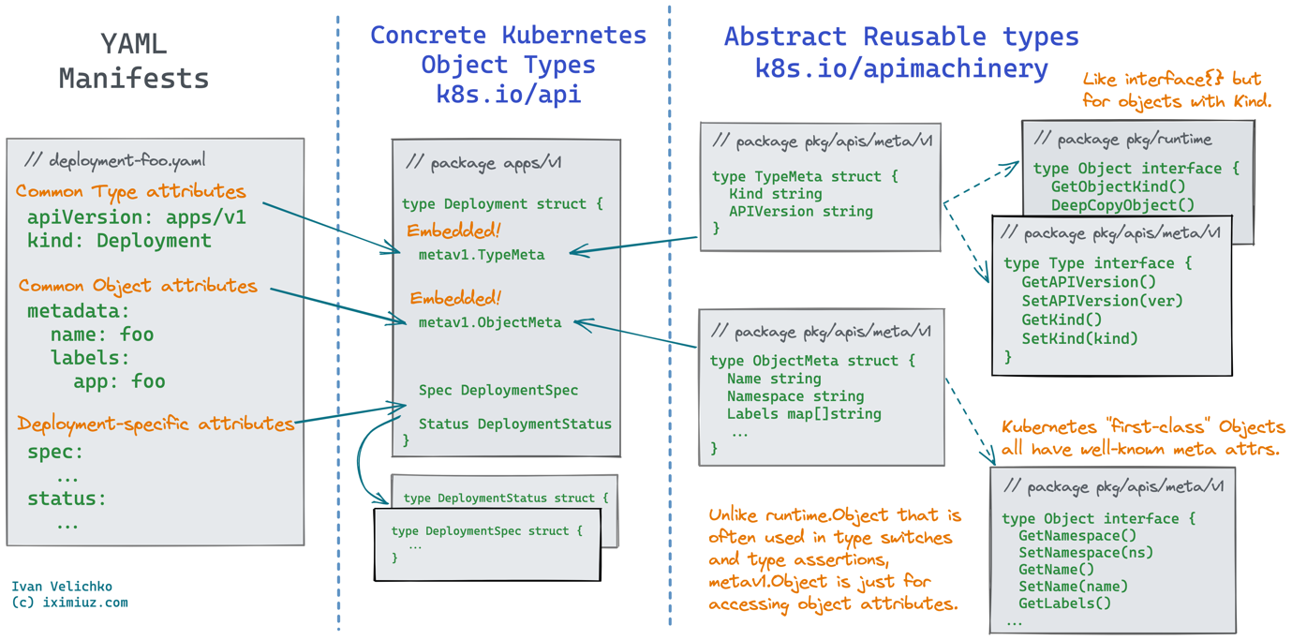

Another handy type defined in the apimachinery module is the interface **[runtime.Object](https://github.com/kubernetes/apimachinery/blob/3d7c63b4de4fdee1917284129969901d4777facc/pkg/runtime/interfaces.go" \l "L302)**. Due to its simplistic definition, it may look useless:

*// pkg/runtime*

type Object interface {

GetObjectKind() schema.ObjectKind

DeepCopyObject() Object

}

But in reality, it's used a lot! Kubernetes code was written long before Go got the support of true generics. So, the runtime.Object is much like the traditional interface{} workaround - it's a generic interface that is widely type-asserted and type-switched in the codebase. And the actual type can be obtained by checking the kind of the underlying object.

A runtime.Object instance can be pointing to any object with the kind attribute - full-fledged Kubernetes Objects, simpler API resources carrying no metadata, or any other kinds of objects with a well-defined object scheme.

Note that while looking similar, meta.Object **cannot be safely down-casted** to the corresponding Kubernetes Object due to a non-zero struct offset.

More useful apimachinery types:

* [PartialObjectMetadata](https://github.com/kubernetes/apimachinery/blob/ea11419e6b79342dfdb688604cedc8c6ac84c5c3/pkg/apis/meta/v1/types.go) struct - combination of meta.TypeMeta and meta.ObjectMeta as a generic way to represent any object with metadata.
* [APIVersions](https://github.com/kubernetes/apimachinery/blob/ea11419e6b79342dfdb688604cedc8c6ac84c5c3/pkg/apis/meta/v1/types.go#L1028), [APIGroupList](https://github.com/kubernetes/apimachinery/blob/ea11419e6b79342dfdb688604cedc8c6ac84c5c3/pkg/apis/meta/v1/types.go" \l "L1046), [APIGroup](https://github.com/kubernetes/apimachinery/blob/ea11419e6b79342dfdb688604cedc8c6ac84c5c3/pkg/apis/meta/v1/types.go" \l "L1056) structs - remember [the API exploration exercise](https://iximiuz.com/en/posts/kubernetes-api-call-simple-http-client/) with kubectl get --raw /apis? These and similar structs are used for types that are Kubernetes API resources, but not Kubernetes Objects (i.e., they have kind and apiVersion attributes but no true Object metadata).
* [GetOptions](https://github.com/kubernetes/apimachinery/blob/ea11419e6b79342dfdb688604cedc8c6ac84c5c3/pkg/apis/meta/v1/types.go#L444), [ListOptions](https://github.com/kubernetes/apimachinery/blob/ea11419e6b79342dfdb688604cedc8c6ac84c5c3/pkg/apis/meta/v1/types.go" \l "L338), [UpdateOptions](https://github.com/kubernetes/apimachinery/blob/ea11419e6b79342dfdb688604cedc8c6ac84c5c3/pkg/apis/meta/v1/types.go" \l "L673), etc. - these structs represent arguments for the corresponding client action on resources.
* [GroupKind](https://github.com/kubernetes/apimachinery/blob/ea11419e6b79342dfdb688604cedc8c6ac84c5c3/pkg/runtime/schema/group_version.go#L120), [GroupVersionKind](https://github.com/kubernetes/apimachinery/blob/ea11419e6b79342dfdb688604cedc8c6ac84c5c3/pkg/runtime/schema/group_version.go#L142), [GroupResource](https://github.com/kubernetes/apimachinery/blob/ea11419e6b79342dfdb688604cedc8c6ac84c5c3/pkg/runtime/schema/group_version.go#L56), [GroupVersionResource](https://github.com/kubernetes/apimachinery/blob/ea11419e6b79342dfdb688604cedc8c6ac84c5c3/pkg/runtime/schema/group_version.go#L96), etc. - simple [data transfer objects](https://en.wikipedia.org/wiki/Data_transfer_object) - tuples containing group, version, kind, or resource strings.

Keep **GroupVersionKind** and **GroupVersionResource** in mind until the [Scheme and RESTMapper](https://iximiuz.com/en/posts/kubernetes-api-go-types-and-common-machinery/#apimachinery-scheme-and-restmapper) discussion - their knowledge will come in handy.

Working with Kubernetes Objects using concrete k8s.io/api types is convenient, but what if:

* You need to work with Kubernetes Objects in a generic way?
* You don't want to or cannot depend on the api module?
* You need to work with Custom Resources that aren't defined in the api module?

The [unstructured.Unstructured](https://github.com/kubernetes/apimachinery/blob/ea11419e6b79342dfdb688604cedc8c6ac84c5c3/pkg/apis/meta/v1/unstructured/unstructured.go) struct for the rescue! This struct allows objects that do not have Go structs *registered* to be manipulated as generic JSON-like objects:

type Unstructured struct {

*// Object is a JSON compatible map with*

*// string, float, int, bool, []interface{}, or*

*// map[string]interface{} children.*

Object map[string]interface{}

}

*// And for the list of objects you can*

*// use the UnstructuredList struct.*

type UnstructuredList struct {

Object map[string]interface{}

Items []Unstructured

}

Under the hood, these two structs are just map[string]interface{}. However, they come with a bunch of handy methods simplifying nested attribute access and JSON marshaling/unmarshaling.

**Example** - [How to work with unstructured Kubernetes Objects in Go code](https://github.com/iximiuz/client-go-examples/blob/5b220c4572d65ea8bf0ad68e369e015902e7521c/crud-dynamic-simple/main.go#L36).

### Type Conversion - Unstructured to Typed and vice versa

Naturally, a need for converting an unstructured object into a struct of a concrete k8s.io/api type (or vice versa) can arise. The [runtime.UnstructuredConverter](https://github.com/kubernetes/apimachinery/blob/ea11419e6b79342dfdb688604cedc8c6ac84c5c3/pkg/runtime/converter.go" \l "L42) interface and its default implementation [DefaultUnstructuredConverter](https://github.com/kubernetes/apimachinery/blob/ea11419e6b79342dfdb688604cedc8c6ac84c5c3/pkg/runtime/converter.go" \l "L77) can help you with that:

type UnstructuredConverter interface {

ToUnstructured(obj interface{}) (map[string]interface{}, error)

FromUnstructured(u map[string]interface{}, obj interface{}) error

}

**Example** - [How to convert unstructured objects into typed and back](https://github.com/iximiuz/client-go-examples/tree/main/convert-unstructured-typed).

### Object Serialization to JSON, YAML, or Protobuf

Another tedious task when working with an API from a statically typed language is marshaling and unmarshaling data structures into and from their wire representation.

A non-trivial amount of apimachinery code is dedicated to this task:

*// pkg/runtime*

*// Encoder writes objects to a serialized form*

type Encoder interface {

Encode(obj Object, w io.Writer) error

Identifier() Identifier

}

*// Decoder attempts to load an object from data.*

type Decoder interface {

Decode(

data []byte,

defaults \*schema.GroupVersionKind,

into Object

) (Object, \*schema.GroupVersionKind, error)

}

type Serializer interface {

Encoder

Decoder

}

Noticed these Object's in the snippet above? Yep, those are runtime.Objects aka Kind-able interface{} instances.

**Examples:**

* [How to serialize a typed Kubernetes Object into JSON](https://github.com/iximiuz/client-go-examples/tree/main/serialize-typed-json)
* [How to serialize a typed Kubernetes Object into YAML](https://github.com/iximiuz/client-go-examples/tree/main/serialize-typed-yaml)
* [How to serialize an unstructured Kubernetes Object into JSON](https://github.com/iximiuz/client-go-examples/tree/main/serialize-unstructured-json)
* [How to serialize an unstructured Kubernetes Object into YAML](https://github.com/iximiuz/client-go-examples/tree/main/serialize-unstructured-yaml)

### Scheme and RESTMapper

The [runtime.Scheme](https://github.com/kubernetes/apimachinery/blob/3d7c63b4de4fdee1917284129969901d4777facc/pkg/runtime/scheme.go" \l "L46) concept pops up here and there when working with client-go, especially when writing controllers (or operators 🤔) that deal with custom resources.

It took me a while to understand its purpose. However, approaching things in the right order helped.

Think about the potential implementation of Unstructured to Typed conversion: there is a JSON-like object, and a corresponding object of some concrete k8s.io/api type needs to be created from it. Probably, the very first step would be to figure out **how to create an empty instance of the typed object using the kind string**.

A naive approach could look like a huge switch statement over all possible kinds (and API groups, actually):

import (

appsv1 "k8s.io/api/apps/v1"

corev1 "k8s.io/api/core/v1"

)

func New(apiVersion, kind string) runtime.Object {

switch (apiVersion + "/" + kind) {

case: "v1/Pod":

return &corev1.Pod{}

case: "apps/v1/Deployment":

return &appsv1.Deployment{}

}

...

}

A smarter approach is to use [reflection](https://pkg.go.dev/reflect). Instead of the switch, a map[string]reflect.Type can be maintained for all registered types:

type Registry struct {

map[string]reflect.Type types

}

func (r \*Registry) Register(apiVersion, kind string, typ reflect.Type) {

r.types[apiVersion + "/" + kind] = typ

}

func (r \*Registry) New(apiVersion, kind string) runtime.Object {

return r.types[apiVersion + "/" + kind].New().(runtime.Object)

}

The advantage of this approach is that it requires no code generation and that new type mappings can be added at runtime.

Now, consider a deserialization problem: a piece of YAML or JSON needs to be converted into a Typed object. The very first step - object creation - will be very similar.

Turns out, creating empty objects by their API Groups and kinds is such a frequent task that it got its own component in the apimachinery module - [runtime.Scheme](https://github.com/kubernetes/apimachinery/blob/3d7c63b4de4fdee1917284129969901d4777facc/pkg/runtime/scheme.go" \l "L46):

*// Scheme defines methods for serializing and deserializing API objects, a type*

*// registry for converting group, version, and kind information to and from Go*

*// schemas, and mappings between Go schemas of different versions.*

type Scheme struct {

gvkToType map[schema.GroupVersionKind]reflect.Type

typeToGVK map[reflect.Type][]schema.GroupVersionKind

unversionedTypes map[reflect.Type]schema.GroupVersionKind

unversionedKinds map[string]reflect.Type

...

}

**The runtime.Scheme struct is such a registry containing the kind to type and type to kind mappings for all kinds of Kubernetes objects**.

Remember, **GroupVersionKind** is just a tuple, i.e., a DTO struct, right?

The runtime.Scheme struct is actually very powerful - it has a whole bunch of methods and implements some foundational interfaces like:

*// ObjectTyper contains methods for extracting*

*// the APIVersion and Kind of objects.*

type ObjectTyper interface {

ObjectKinds(runtime.Object) ([]schema.GroupVersionKind, bool, error)

Recognizes(gvk schema.GroupVersionKind) bool

}

*// ObjectCreater contains methods for instantiating*

*// an object by kind and version.*

type ObjectCreater interface {

New(kind schema.GroupVersionKind) (out Object, err error)

}

However, the runtime.Scheme is not almighty. It has mappings from *kinds to types*, but what if instead of *kind* only the *resource name* is known?

That's where the **[RESTMapper](https://github.com/kubernetes/apimachinery/blob/cc08b72c0267a385c177df9d9467a066563c1924/pkg/api/meta/interfaces.go" \l "L113)** kicks in:

type RESTMapper interface {

*// KindFor takes a partial resource and returns the single match. Returns an error if there are multiple matches*

KindFor(resource schema.GroupVersionResource) (schema.GroupVersionKind, error)

*// KindsFor takes a partial resource and returns the list of potential kinds in priority order*

KindsFor(resource schema.GroupVersionResource) ([]schema.GroupVersionKind, error)

...

ResourceSingularizer(resource string) (singular string, err error)

}

The RESTMapper is also some sort of a registry. However, it maintains mapping of *resources to kinds*. So, feeding a string like apps/v1/deployments to the mapper gives the API Group apps/v1 and the kind Deployment. The RESTMapper also can deal with resource shortcuts and singularization: po, pod, and pods can be registered as aliases for the same resource.

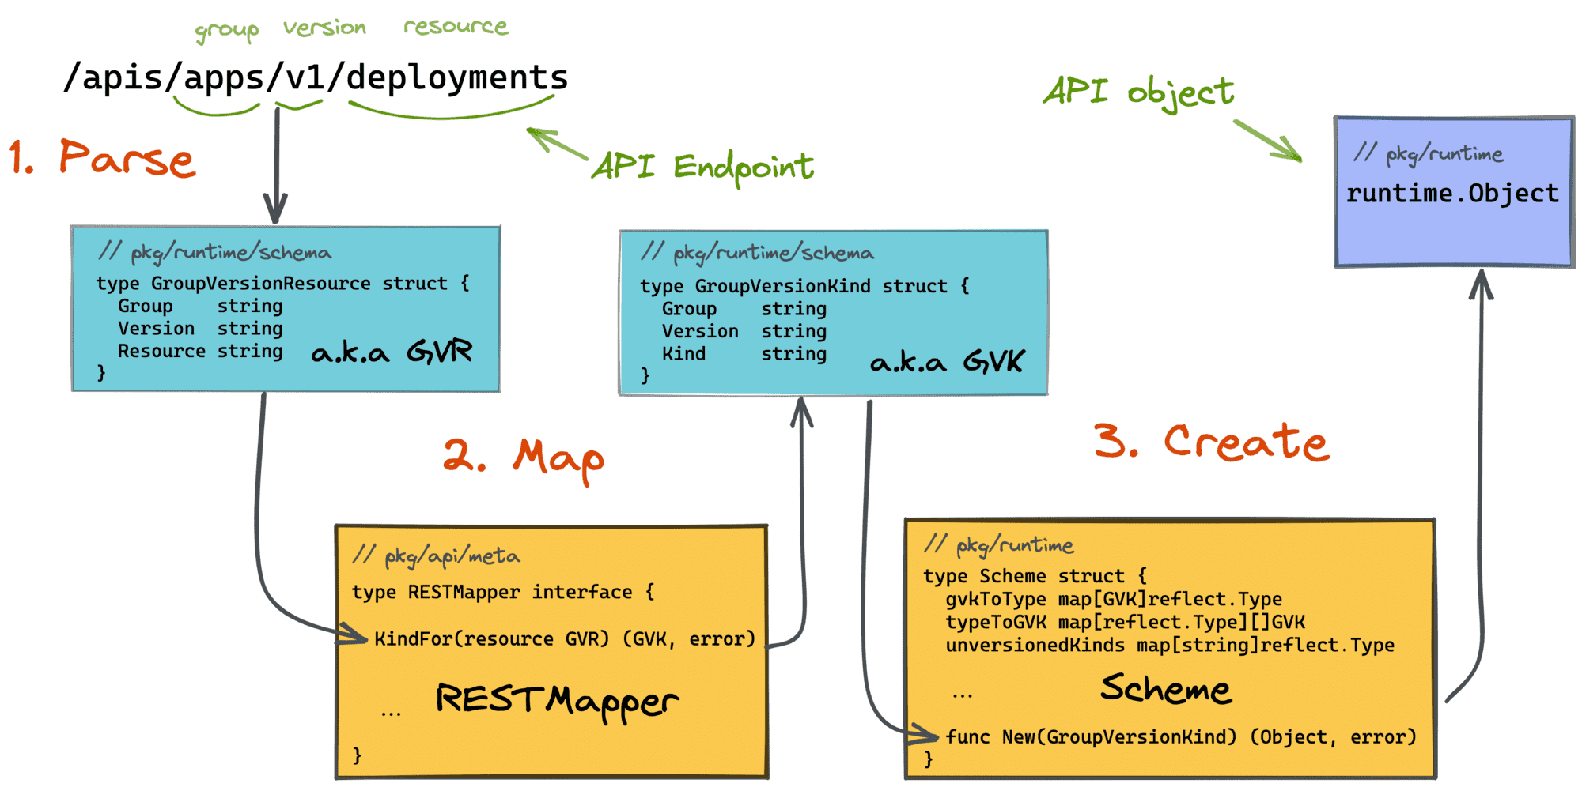

In the wild, there is often a global singleton runtime.Scheme. However, it seems like the apimachinery module itself tries to avoid state - it defines RESTMapper and Scheme structs, but does not instantiate them.

Unlike runtime.Scheme that's widely used by the apimachinery module itself, RESTMapper is not used internally, at least at the moment.

### Field and Label Selectors

Types, creation, and matching logic for fields and labels also live in the apimachinery module. For instance, here is what can be done with the [k8s.io/apimachinery/pkg/labels](https://github.com/kubernetes/apimachinery/blob/cc08b72c0267a385c177df9d9467a066563c1924/pkg/labels/labels.go) package:

lbl := labels.Set{"foo": "bar"}

sel, \_ = labels.Parse("foo==bar")

if sel.Matches(lbl) {

fmt.Printf("Selector %v matched label set %v\n", sel, lbl)

}

**Examples:**

* [How to use label sets and label selectors](https://github.com/iximiuz/client-go-examples/tree/main/label-selectors)
* [How to use field sets and field selectors](https://github.com/iximiuz/client-go-examples/tree/main/field-selectors)

### API Error Handling

Working with the Kubernetes API in code is impossible without handling its errors properly. The API server might be completely gone, requests may be unauthorized, objects might be missing, and concurrent updates may conflict. Luckily, the [k8s.io/apimachinery/pkg/api/errors](https://github.com/kubernetes/apimachinery/blob/cc08b72c0267a385c177df9d9467a066563c1924/pkg/api/errors/errors.go) package defines some handy utility functions to deal with the API errors. Here is an example:

\_, err = client.

CoreV1().

ConfigMaps("default").

Get(

context.Background(),

"this\_name\_definitely\_does\_not\_exist",

metav1.GetOptions{},

)

if !errors.IsNotFound(err) {

panic(err.Error())

}

**Example** - [How to handle Kubernetes API errors.](https://github.com/iximiuz/client-go-examples/tree/main/error-handling)

### Miscellaneous Utils

Last but not least, the apimachinery/pkg/util package is full of useful stuff. Here are some examples:

* [util/wait](https://github.com/kubernetes/apimachinery/blob/cc08b72c0267a385c177df9d9467a066563c1924/pkg/util/wait/wait.go) package eases the task of waiting for resources to appear or to be gone, with retries and proper backoff/jitter implementation.
* [util/yaml](https://github.com/kubernetes/apimachinery/blob/cc08b72c0267a385c177df9d9467a066563c1924/pkg/util/yaml/decoder.go) helps to unmarshal YAML or convert it into JSON.

## Summarizing

The k8s.io/api and k8s.io/apimachinery packages is a good starting place to learn how to work with Kubernetes objects in Go. If you need to write your first controller, jumping straight to client-go, or even to [controller-runtime](https://github.com/kubernetes-sigs/controller-runtime) or [kubebuilder](https://github.com/kubernetes-sigs/kubebuilder) will likely make the learning experience too rough - there might be way too many knowledge gaps. However, taking a look and playing around with the api and apimachinery packages first will help you keep peace of mind during the rest of the journey

# **Kubernetes API Server Authentication and Authorization Mechanism**

kube-apiserver is the gateway component of kubernetes and is the only entry point for kubernetes cluster resource operations, so some processes such as authentication and authorization are obviously implemented based on this component. kubernetes clusters basically perform all operations through the apiserver component, which provides an API in the form of HTTP RESTful for clients inside and outside the cluster to call. kubernetes provides three steps of security for accessing the API: authentication, authorization, and admission control, which are verified when users request apiserver using kubectl, client-go, or the REST API.

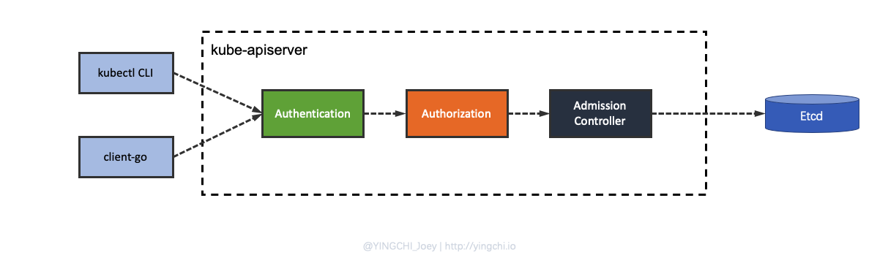

* Authentication solves the problem of **identifying the user**.
* Authorization is **specifying what permissions a user has**.
* Admission control is **acting on resource objects in kubernetes**.

**Kubernetes API Server Authentication Mechanism (Authentication)**

Once a TLS connection is established, the request enters the authentication phase, where the request payload is checked by one or more authenticator modules.

Authentication modules are configured by the administrator during cluster creation, and a cluster may have multiple authentication modules configured, each of which will attempt to authenticate in turn until one of them succeeds.

The main authentication modules include client certificates, passwords, plain tokens, bootstrap tokens, and JWT tokens (for service accounts). The client certificate is used by default and is the most common scheme.

All of kubernetes’ current authentication policies are shown below.

* X509 client certs
* Static Token File
* Bootstrap Tokens
* Static Password File
* Service Account Tokens
* OpenId Connect Tokens
* Webhook Token Authentication
* Authticating Proxy
* Anonymous requests
* User impersonation
* Client-go credential plugins

### Kubernetes common authentication mechanisms

#### X509 client certs

**X509 client certs authentication is used for some client access to apiserver and between cluster components, such as when kubectl requests apiserver**.

Target audience: **External users**.

X509 is a digital certificate format standard that is used in the SSL certificates that HTTPS relies on. x509 client certificate authentication is the most used and relatively secure of all kubernetes authentication methods.

Some of the kubernetes deployment tools kubeadm, minkube, etc. are based on certificate authentication. Client-side certificate authentication is called TLS two-way authentication, which means that the server and client verify the correctness of each other’s certificates and coordinate communication encryption schemes if both are correct. The most commonly used X509 certificate creation tools are openssl, cfssl, etc.

#### Service Account Tokens

**serviceaccounts is used for authentication when accessing apiserver in pods, for example when using custom controllers**.

Target audience: **internal users**

There are cases where we want to access the apiserver from inside the pod to get information about the cluster and even make changes to the cluster. In this case, kubernetes provides a special authentication method: serviceaccounts.

Serviceaccounts are namespace oriented. When each namespace is created, kubernetes automatically creates a default serviceaccount under that namespace; and the serviceaccount can only access the resources of that namespace.

Serviceaccounts are a resource in a kubernetes cluster, just like pods, services, and deployments, and users can create their own serviceaccounts.

serviceaccounts contain three main elements: namespace, token, and ca. Each serviceaccount corresponds to a secrets.

Each serviceaccounts corresponds to a secrets, and namespace, token and ca information are stored in secrets and encoded in base64. namespace specifies the namespace where the pod is located, ca is used to verify the apiserver’s certificate, and token is used for authentication. are stored in the pod’s filesystem via mount, and all three are stored in the /var/run/secrets/kubernetes.io/serviceaccount/ directory.

**Kubernetes API Server Authorization Mechanism (Authorization)**

After a request is authenticated, the next step is to confirm that the operation is allowed to be performed, i.e. **Authorization**.

For authorizing a request, Kubernetes focuses on three main aspects.

* **Username of the requestor**
* **Request action**
* **The object affected by the action**

The username is extracted from the header of the embedded token, the action is one of the HTTP verbs mapped to a CRUD operation (e.g. GET, POST, PUT, DELETE), and the object is one of the valid Kubernetes resource objects.

Kubernetes determines authorization based on a presence policy. By default, Kubernetes follows a closed and open philosophy, which means that an explicit permission policy is required to access resources.

Similar to authentication, authorization is configured based on one or more modules, such as ABAC mode, RBAC mode, and Webhook mode. When administrators create clusters, they configure authorization modules that integrate with API sever. If multiple modules are in use, Kubernetes checks each module and if any of them authorizes the request, the request is approved. If all modules reject the request, the request is rejected (HTTP status code 403).

kubernetes currently supports the following four authorization mechanisms.

* Node
* ABAC
* RBAC
* Webhook

### kubernetes common authorization mechanisms

#### RBAC (Role-Based Access Control)

RBAC, or Role-Based Access Control, is a mechanism for customizing roles and associating them with specific user, group, and serviceaccounts for the purpose of privilege control.

There are three important concepts in RBAC.

* **Role**: a role, which is actually a **set of rules** that defines a set of permissions to operate on Kubernetes API objects.
* **Subject**: the actee, which includes **user**, **group**, **serviceaccounts**, which in layman’s terms are the users identified in the authentication mechanism.
* **RoleBinding**: defines the binding relationship between “**Role**” and “**Subject**”, that is, the user and the operation privileges are bound.

RBAC actually binds the subject to the role by creating a role through RoleBinding. The following diagram shows several types of binding relationships in RBAC.

### kubernetes common authorization mechanisms

#### RBAC (Role-Based Access Control)

RBAC, or Role-Based Access Control, is a mechanism for customizing roles and associating them with specific user, group, and serviceaccounts for the purpose of privilege control.

There are three important concepts in RBAC.

* **Role**: a role, which is actually a **set of rules** that defines a set of permissions to operate on Kubernetes API objects.
* **Subject**: the actee, which includes **user**, **group**, **serviceaccounts**, which in layman’s terms are the users identified in the authentication mechanism.
* **RoleBinding**: defines the binding relationship between “**Role**” and “**Subject**”, that is, the user and the operation privileges are bound.

RBAC actually binds the subject to the role by creating a role through RoleBinding. The following diagram shows several types of binding relationships in RBAC.

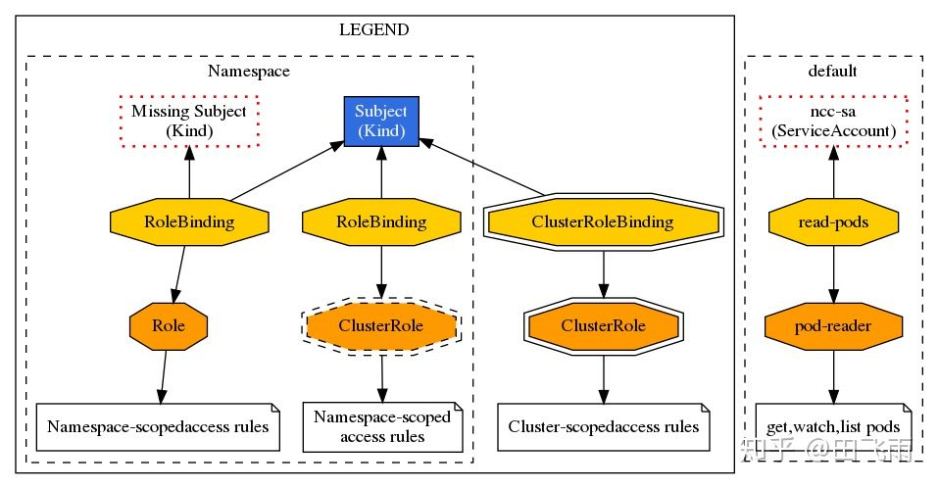

## Admission Control

Admission Control is the last step of the request. Admission Control has many built-in modules that can act on the object’s “CREATE”, “UPDATE”, " DELETE", “CONNECT” four phases. During this process, if any of the Admission Control modules rejects, then the request is immediately rejected. Once the request has passed all the Admission Controllers it is written to the object store.

The Sidecar injection process for Service Grid Istio technology relies on Kubernetes’ Admission Control implementation.

The Admission Controller is a gateway that intercepts API Server requests (authenticated) and can modify the request object or deny the request. In short, it can be thought of as an interceptor, similar to a middleware in a web framework, which is a means for the Kubernetes API Server to intercept requests.

Why did Kubernetes introduce admission as a mechanism?

1. Although Kubernetes has Authentication & Authorization, Authentication & Authorization runs in the filter and **can only get the http request header and certificate, but not the request body**. So you can’t do any operation on the requested object, because you can’t get the object.
2. The Admission Controller runs in the API Server’s add, delete, and check handler, and can naturally manipulate the API resource.

After the API Server receives the client request, it will first authenticate and authorize the request, and only after the authentication and authorization are passed will it proceed to the subsequent endpoint handler processing. The flow of kube-apiserver processing resource requests is as follows.

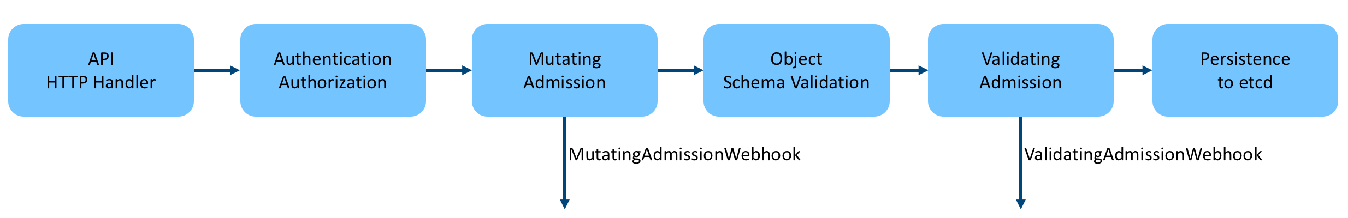

As you can see, after Authentication & Authorization, the request is handed over to the Admission Controller for further processing, which involves two important phases of Admission, Mutating and Validating, the differences of which are as follows.

* Mutating: allows modification of the request content.
* Validating: does not allow the request to be modified, but can determine whether to proceed with the request or reject it based on the content of the request.

# **Kubernetes' RBAC mechanism**

When I was doing PaaS platform development, I was involved in tenant privilege management, and considering that Kubernetes provides RBAC (role-based access control) mechanism by default, I thought how to make good use of RBAC of Kubernetes to achieve it. However, when I started to learn this knowledge, I encountered some problems, such as Role and ClusterRole, Role Binding and ClusterRoleBinding, and many concepts are rather vague.

As we learn more about them and practice, we can sort out the relationship between them. This article is to share what we have learned during this period.

### RBAC (Role-Based Access Control)

RBAC, Role-Based Access Control, or **Role-Based Access Control**, is achieved by customizing a Role with certain specific Permissions and then associating the Role with a specific Subject (user, group, serviceaccounts…) The purpose of access control is achieved by customizing a Role with certain Permissions and then associating the Role with a specific Subject (user, group, serviceaccounts…).

There are three important concepts in RBAC.

* **Role**: Role, which is essentially a collection of **a set of rule permissions**. Note: In RBAC, a Role only declares grant permissions, not negative rules.
* **Subject**: the acted upon, including **user**, **group**, which in layman’s terms is the user identified in the authentication mechanism.
* **RoleBinding**: defines the binding relationship between “**Role**” and “**Subject**”, that is, the user and the operation privileges are bound.

RBAC actually binds the subject to the role by creating a role through RoleBinding. The following diagram shows several types of binding relationships in RBAC.

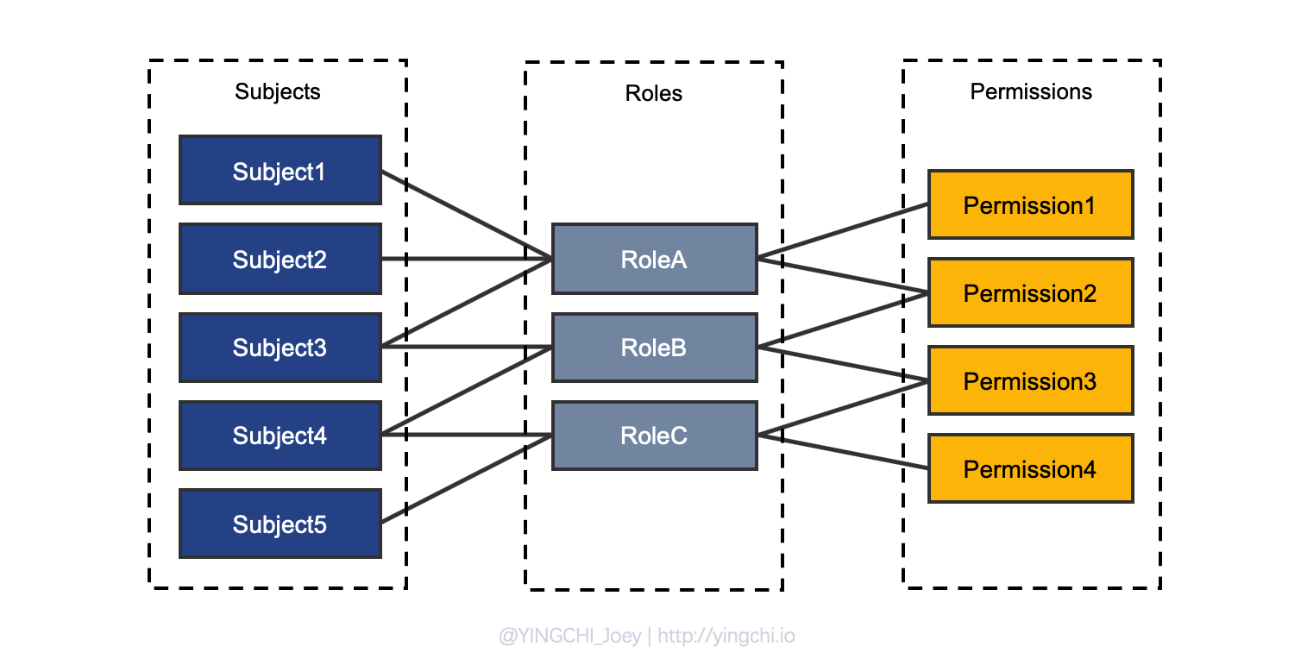

## Kubernetes RBAC

Now let’s take a fresh look at the RBAC implementation from a Kubernetes perspective.

The whole process of RBAC role creation and role binding in Kubernetes is relatively clear, and the RBAC configuration is presented to the administrator in the form of a resource configuration, so we only need to define some configuration files. First, let’s look at the RBAC configuration relationship diagram in Kubernetes.

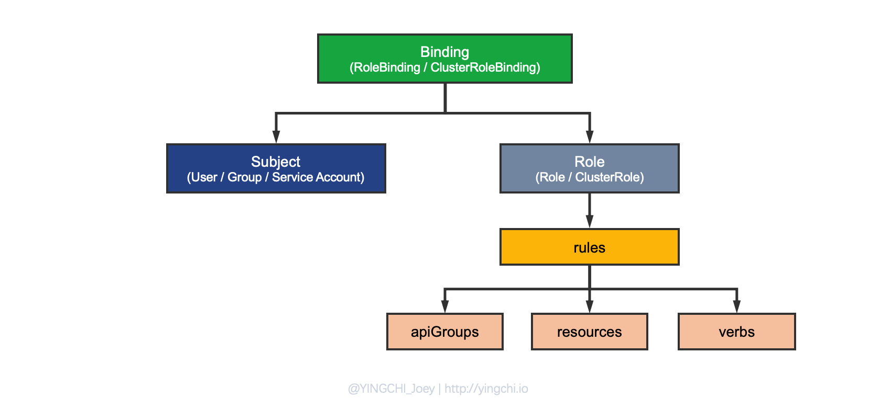

As you can see in the figure, the process of implementing a custom RBAC for Kubernetes involves several concepts that were actually mentioned at the beginning, but which are defined more specifically in Kubernetes, and which are the focus of attention.

### Subject

Subjects in kubernetes include User, Group, and Service Account, the first two are well understood, Service Account is actually the difference between User Account, resources in Kubernetes can also be treated as a Subject, such as a Pod For example, when a Pod needs to operate cluster resources, it uses a Service Account.

Kubernetes does not implement direct management of User Accounts, and requires administrators to create User Accounts manually.

### Role

A role is essentially a collection of rule permissions that are bound to a specific Subject, thus giving the Subject a corresponding set of permissions.

In Kubernetes, Roles are divided into two categories.

* Role: Role, which can be understood as a Namespace Role. A Role is defined by specifying the Namespace, that is, the Role is defined inside the Namespace, so the set of rule permissions it defines is also for the resources under the Namespace where it is defined.
* As the name implies, this type of Role is defined under the entire Cluster, and there is no need to specify a specific Namespace when defining a Cluster Role.

Role and ClusterRole Example.

apiVersion: rbac.authorization.k8s.io/v1

kind: ClusterRole

metadata:

name: pod-reader

rules:

- apiGroups: [""]

resources: ["pods"]

verbs: ["get", "watch", "list"]

apiVersion: rbac.authorization.k8s.io/v1

kind: Role

metadata:

namespace: ns-a

name: pod-reader

rules:

- apiGroups: [""]

resources: ["pods"]

verbs: ["get", "watch", "list"]

Note: ClusterRole does not mean that the scope of permission control is the entire Cluster, but also has a relationship with the type of Binding to be discussed later, where ClusterRole should be understood as a global quantity that can be applied under a Namespace (to play the role of reuse) and can be applied under the scope of the Cluster.

The key step in the definition of each Role is to specify the rules that the Role has, and the permission rules in Kubernetes need to be specified as follows.

* apiGroups: resource groups, "" defaults to core group resources, others such as apps, etc.
* resources: resources, such as pods, deployments, services, secrets, etc.
* verbs: action verbs, such as get, list, watch, create, delete, update, etc.

### Binding

Binding, conceptually well understood, is the binding of a Role with defined rule permissions to a specified Subject, thus giving the Subject a set of permissions.

Binding in kubernetes is divided into two types.

* RoleBinding: Binding a Role/ClusterRole to a Subject, which takes effect on a specific Namespace scope resource.
* ClusterRoleBinding: Binding a ClusterRole to a Subject, which takes effect on the Cluster scope resource.

Again.

**The scope of permission control (Namespace/Cluster) in Kubernetes is determined by the type of Binding, not by Role and ClusterRole, which is important to remember**.

### Analysis of RBAC schemes acting on Namespace scope

#### Method 1: Combination of Role + RoleBinding

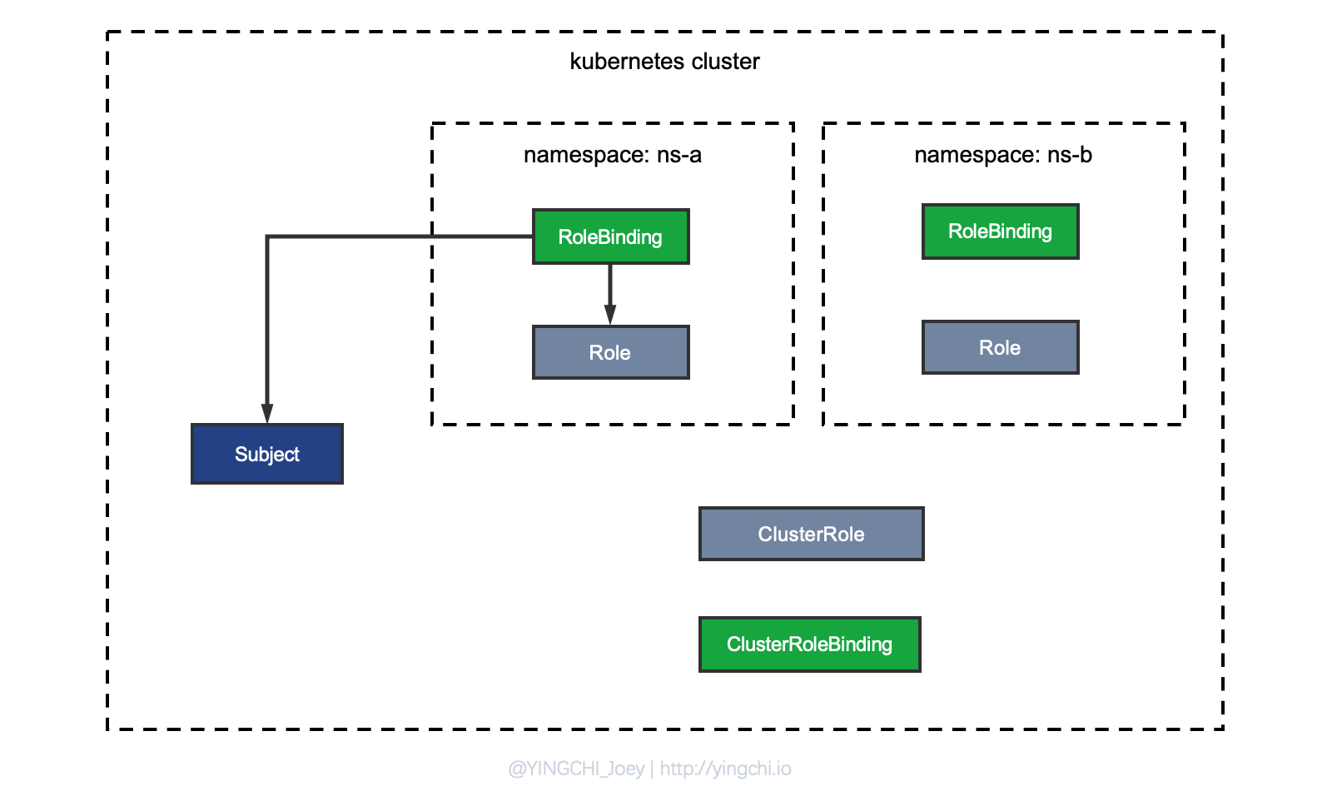

As you can see above, this approach is more intuitive, because as I said before, a Role in Kubernetes should be understood as a Namespace Role, which is defined under the Namespace, so if you want to implement binding between Subjects and Roles in the Namespace scope, it’s just a matter of configuring a RoleBinding.

kind: RoleBinding

apiVersion: rbac.authorization.k8s.io/v1

metadata:

name: pods-reader-binding

namespace: ns-a

subjects:

- kind: User

name: abhishek

apiGroup: rbac.authorization.k8s.io

roleRef:

kind: Role

name: pod-reader

apiGroup: rbac.authorization.k8s.io

#### Method 2: Combination of ClusterRole + RoleBinding (recommended)

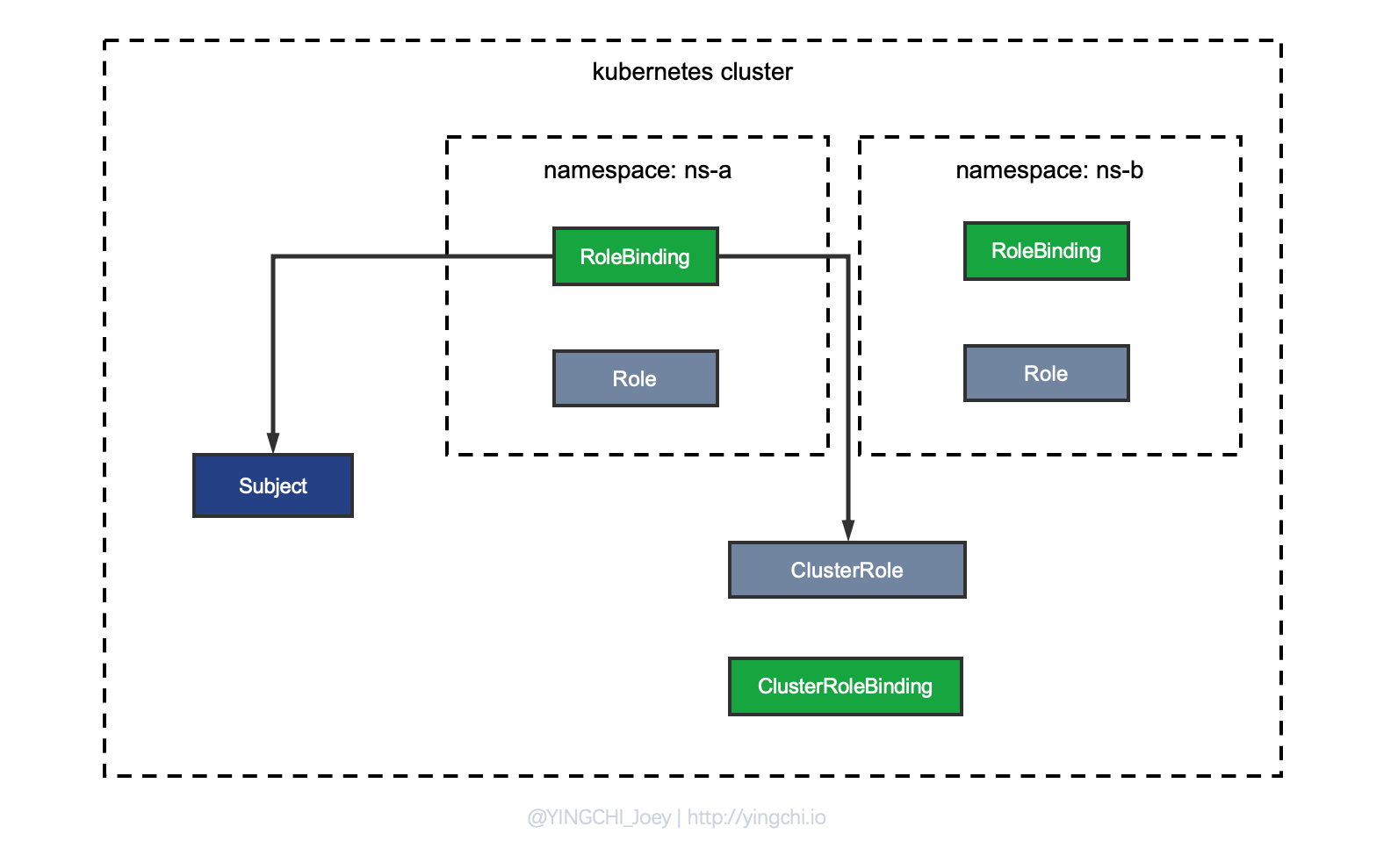

Once you hear ClusterRole, many people will subconsciously think that it is about cluster-wide permission control, but in fact, the scope of permission control is not directly related to the type of Role, ClusterRole, which is essentially a role defined globally, can act under Namespace, can be reused by multiple Namespaces, and can also Cluster.

We now need to implement the binding of Subject & Role in the scope of Namespace, that is, to control the scope of authority of ClusterRole at the level of Namespace, so use RoleBinding to bind Subject to ClusterRole can be achieved.

Configuration example:

kind: RoleBinding

apiVersion: rbac.authorization.k8s.io/v1

metadata:

name: pods-reader-binding

namespace: ns-a

subjects:

- kind: User

name: yingchi

apiGroup: rbac.authorization.k8s.io

roleRef:

kind: ClusterRole

name: pod-reader

apiGroup: rbac.authorization.k8s.io

#### method analysis

Why do you recommend using the combination of ClusterRole + RoleBinding?

Let’s think about a problem. If a PodReader Role is designed to have the permission to get/list/watch the Pods under the current Namespace, how should it be designed if both namespaces need such a Role?

Using the first approach described above, each namespace would need to define a PodReader Role.

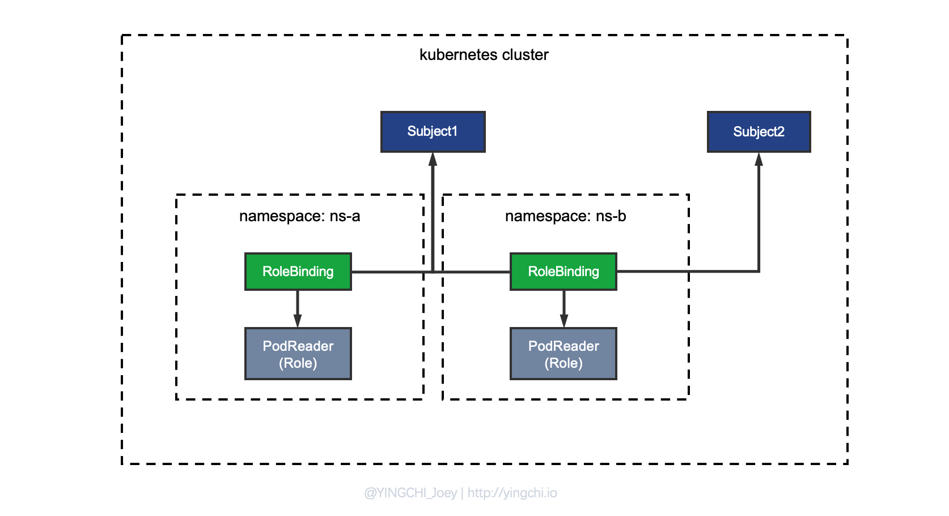

There is an obvious drawback to this: the rules permissions of PodReader are actually the same under each Namespace, but due to the limitations of Role, it must be defined separately under each Namespace, which is a waste of resources and an inelegant process, so how can we reuse PodReader as a Role? So, there is the second method.

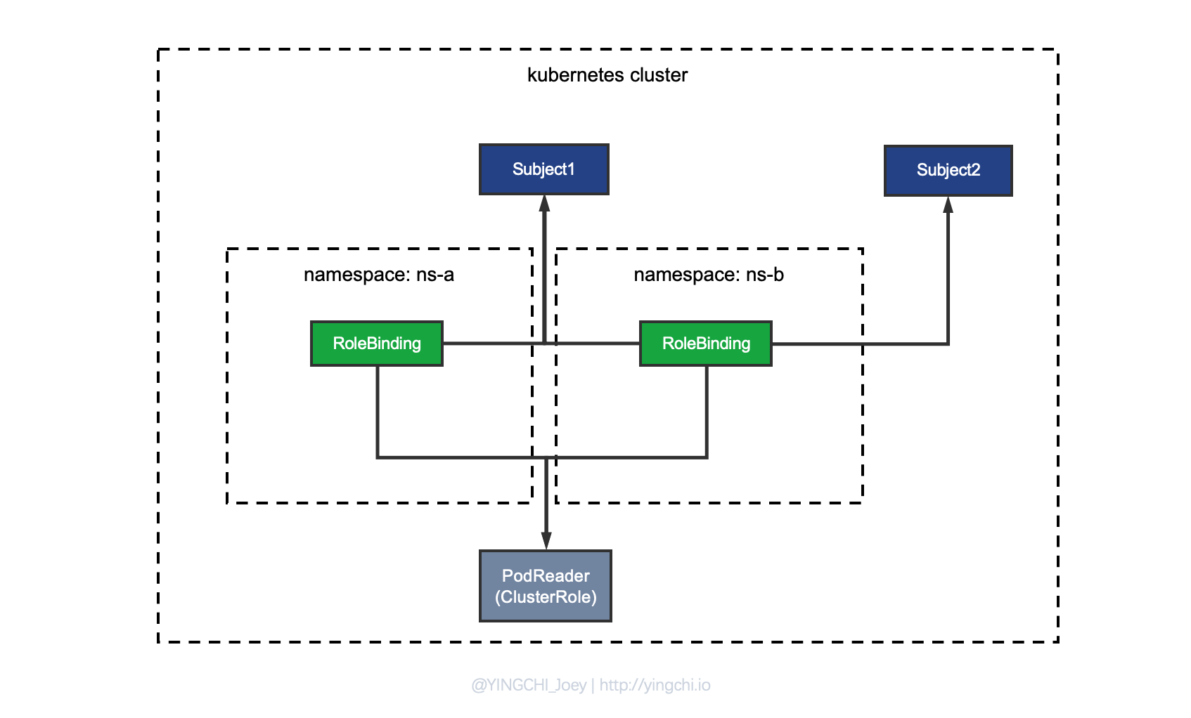

As shown in the figure, that is, the PodReader is defined as a ClusterRole, and then different Subjects are bound to the same ClusterRole under different Namespaces through RoleBinding.

#### Summary

If a custom Role is used in many Namespaces, then it is recommended to use the combination of ClusterRole + RoleBinding to achieve the reuse of the Role, if a Namespace really has to define a separate private Role, then use the combination of Role + RoleBinding, but If a Namespace has to define a separate private Role, then use the combination of Role + RoleBinding, but then the Role will be more limited.

### Analysis of cluster-wide RBAC scenarios

There is only one solution, which is via **ClusterRoleBinding + ClusterRole**.

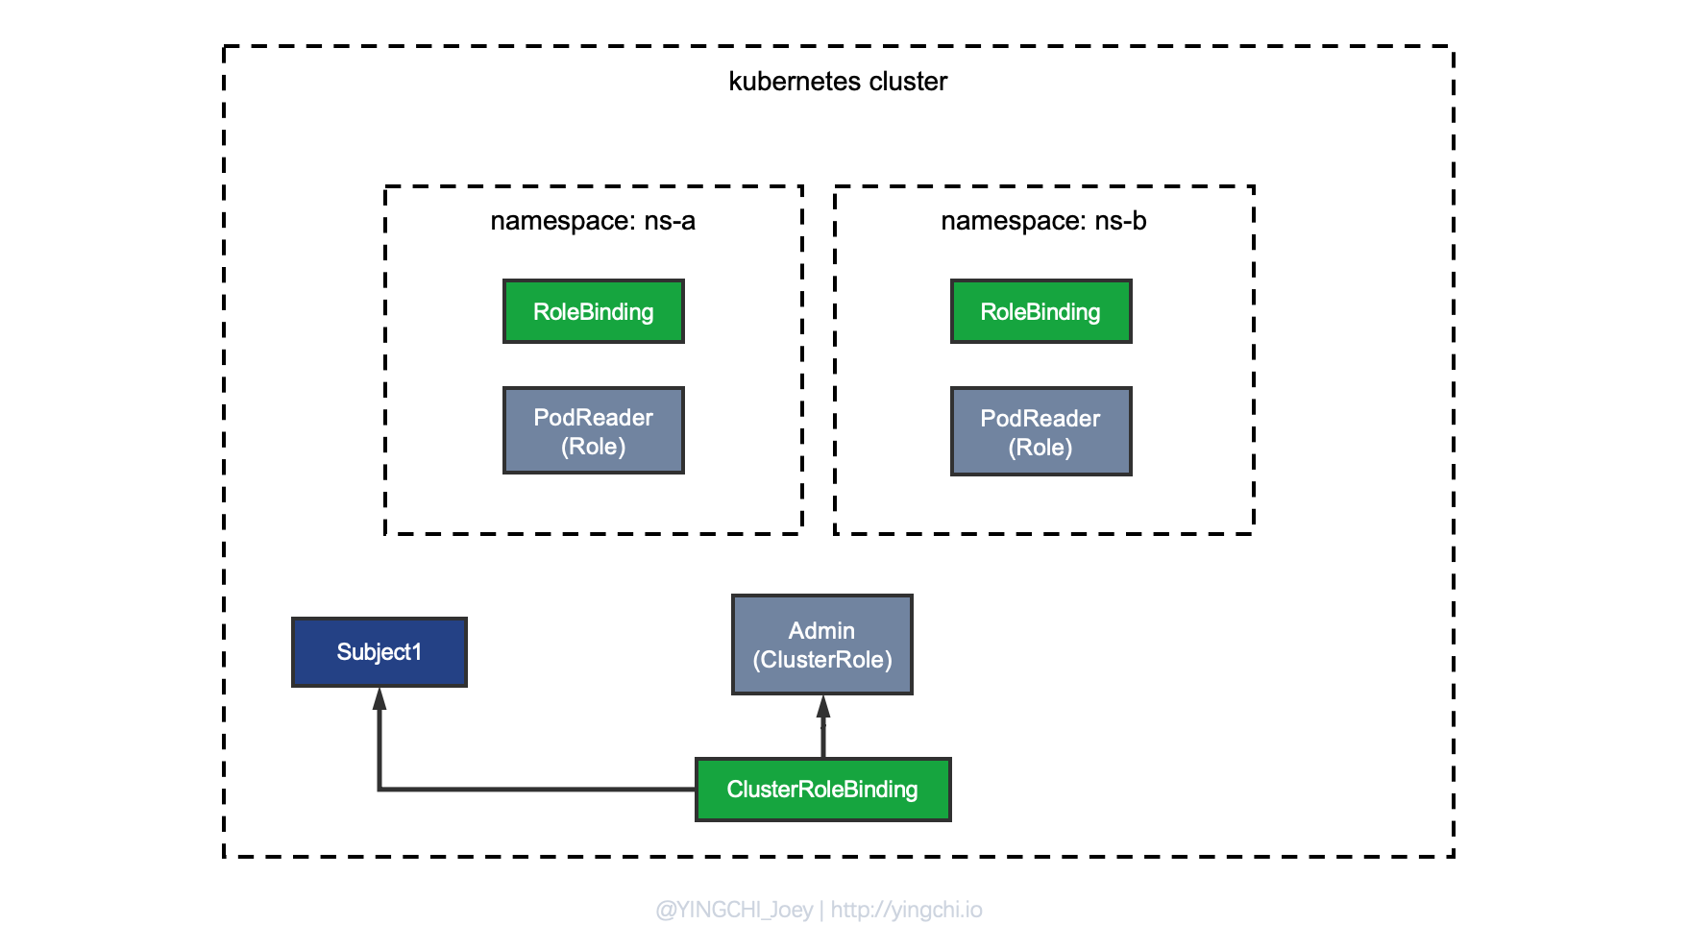

Note where I drew **ClusterRoleBinding** in the diagram. When I introduced the concept of Binding earlier, I mentioned that the scope of permission control (Namespace/Cluster) in Kubernetes is determined by the type of Binding, not by Role and ClusterRole\*\* . If you want to implement cluster-wide RBAC, you must use ClusterRoleBinding, and note that when you bind by ClusterRoleBinding, you are only allowed to bind to the ClusterRole role, which can be simply interpreted as a global method that can only use the global amount of ClusterRole.

kind: ClusterRoleBinding

apiVersion: rbac.authorization.k8s.io/v1

metadata:

name: cluster-admin-biding

subjects:

- kind: User

name: abhishek

apiGroup: rbac.authorization.k8s.io

roleRef:

kind: ClusterRole

name: cluster-admin

apiGroup: rbac.authorization.k8s.io

To learn about the Kubernetes RBAC mechanism, we must first start with the basic RBAC concept and understand the essence of the RBAC permission management mechanism, i.e., the relationship between **subject-role-permission**, and on this basis, learn the implementation of RBAC for Kubernetes. Then, we will understand the difference between RoleBinding and ClusterRoleBinding, remembering that the scope of permission control in Kubernetes RBAC is not determined by Role, but by the type of Remember that the scope of permission control in Kubernetes RBAC is not determined by the Role, but by the type of Binding.

**Init Containers**

In a multi-container pod, each container is expected to run a process that stays alive as long as the POD's lifecycle. For example in the multi-container pod that we talked about earlier that has a web application and logging agent, both the containers are expected to stay alive at all times. The process running in the log agent container is expected to stay alive as long as the web application is running. If any of them fails, the POD restarts.

But at times you may want to run a process that runs to completion in a container. For example a process that pulls a code or binary from a repository that will be used by the main web application. That is a task that will be run only one time when the pod is first created. Or a process that waits for an external service or database to be up before the actual application starts. That's where **initContainers**comes in.

An **initContainer**is configured in a pod like all other containers, except that it is specified inside a initContainers section, like this:

apiVersion: v1

kind: Pod

metadata:

name: myapp-pod

labels:

app: myapp

spec:

containers:

- name: myapp-container

image: busybox:1.28

command: ['sh', '-c', 'echo The app is running! && sleep 3600']

initContainers:

- name: init-myservice

image: busybox

command: ['sh', '-c', 'git clone <some-repository-that-will-be-used-by-application> ;']

When a POD is first created the initContainer is run, and the process in the initContainer must run to a completion before the real container hosting the application starts.

You can configure multiple such initContainers as well, like how we did for multi-pod containers. In that case each init container is run **one at a time in sequential order**.

If any of the initContainers fail to complete, Kubernetes restarts the Pod repeatedly until the Init Container succeeds.

apiVersion: v1

kind: Pod

metadata:

name: myapp-pod

labels:

app: myapp

spec:

containers:

- name: myapp-container

image: busybox:1.28

command: ['sh', '-c', 'echo The app is running! && sleep 3600']

initContainers:

- name: init-myservice

image: busybox:1.28

command: ['sh', '-c', 'until nslookup myservice; do echo waiting for myservice; sleep 2; done;']

- name: init-mydb

image: busybox:1.28

command: ['sh', '-c', 'until nslookup mydb; do echo waiting for mydb; sleep 2; done;']

Read more about initContainers here. And try out the upcoming practice test.

<https://kubernetes.io/docs/concepts/workloads/pods/init-containers/>